**PROJECT REPORT**

On

**MEDIALOCATE CONNECTOR**

Towards partial fulfillment of the requirement for the award of degree of

**Master of Computer Applications (MCA)**

**Under the guidance of:**

**Dr. MONICA MEHROTRA**

**Submitted by:**

**SHARA RIZVI**

**Id- 20162740, RollNo- 16MCA035**

**EnrNo- 16-0302**

**Academic Session**: 2016 – 2019



**Department of Computer Science**

**Faculty of Natural Sciences**

**JAMIA MILLIA ISLAMIA**

**May, 2019**

**CANDIDATE DECLARATION**

I, Shara Rizvi, student of M.C.A hereby declare that the project report entitled **“MediaLocate Connector”** which is submitted by me to the Department of Computer Science, Jamia Millia Islamia, New Delhi, in partial fulfillment of the requirement of the degree of **Master of Computer Applications (MCA)**, is a record of the original bonafide work carried out by me and have not been submitted in part or full to any other university or institute for the award of any degree or diploma.

**SHARA RIZVI**

Id-20162740

RollNo- 16MCA035

EnrNo- 16-0302

Date: 13th May, 2019

Place: New Delhi

**CERTIFICATE**

On the basis of declaration made by the student **Shara Rizvi,** Ihereby certify that the project report entitled **“MediaLocate Connector”** submitted by **Shara Rizvi** to the Department of Computer Science, Jamia Millia Islamia, New Delhi, for the partial fulfillment of the requirements of the degree of **Master of Computer Applications (MCA)**, is carried out by her under my/our guidance and supervision. The report has reached the requisite standards for submission.

**Dr. Monica Mehrotra**

(Internal Supervisor)

Date: 13th May, 2019

Place: New Delhi

**ACKNOWLEDGEMENT**

The satisfaction and euphoria that accompany the development of any task would be incomplete without the mention of the people who make it possible, whose constant guidance and encouragement crowned my efforts with success. I feel indebted to a lot of people who during the course of our project not only held us in good stead but also provided us with invaluable services both personal and professional.

My first vote of thanks goes to my Parents, with every gesture, every word, every pat on the back, they have always tried to inspire us for better things and attain them.

I wish to place on record our whole hearted gratitude to **Dr. Monica Mehrotra,** my project guide for making available every facility that I required during the course of my project. Also, I am extremely thankful to you, for extending your kind guidance and words of wisdom from your treasure trove of experience. With friendly advice and guidance at every step, their presence was a welcome sight throughout the project.

I would like to thank **Mr. Jatin Gupta** and **Miss. Dipti Narang** for assigning me the project at **TO THE NEW** and constantly encouraging me to learn and understand the methods to handle the tasks related to the project, besides taking out time from their extremely busy schedule handling their own respective works.

I also would like to specially mention **Mr. Ankur Rajput** and **Mr. Mukesh Kumar Sharma** whose patience in explaining the functionalities of the project along with his encouragement and support while I was working on my project helped me become well-versed with everything.

I am thankful to the teaching staff at Department of Computer Science which has helped me in successfully completing this project.  I would like to extend sincere esteems to the staff in the laboratory and the library for their constant support.

Finally, I would like to bind up by paying my heartfelt thanks and prayers to the Almighty, without whose willing nothing is possible in this world and all my dear friends for their support.

SHARA RIZVI

# **TABLE OF CONTENTS**

**CHAPTER 1: INTRODUCTION AND OBJECTIVES**

**1.1 Statement of the proposed system**

In the current scenario where Content Management Systems are of great scope and use in development for heavy content applications, our client, Marcello, proposed requirement of an **interface** which can act as a **connector** between his server (**MediaLocate** – www.medialocate.com) and our Content Management System (**AEM**- Adobe Experience Manager).

The idea was to store bulk of content in the CMS which can be sent to MediaLocate server in the form of XMLs where those **XMLs** would be distributed to various vendors for **Human Translation** to different languages and are sent back as XMLs (this time translated) and these translated XMLs received by the connector are again converted to their **original format** in AEM connector.

**1.2 Project Description**

The **MediaLocate Connector** is a web application that facilitates the translation process between content management systems (AEM – Adobe Experience Manager) and MediaLocate Tracking Database (MTD). The files sent from **MediaLocate Connector** are received as XMLs at MediaLocate Server and are translated and sent back to MediaLocate Connector where they are converted back to their original format and stored.

* + 1. **Definitions, Acronyms,** and **Abbreviations:**
* **MTD** – MediaLocate Tracking Database Application, MTD is the application framework used by MediaLocate as Project Lifecycle tool to manage translation projects within MediaLocate.
* **TMA** – Translation Management Automation, TMA is the WebService or API to the MTD.
* **MyMedialocate** – MyMedialocate is the client view or portal to the MTD. It provides client relevant information through this portal.
* **CMS** – Content Management System, a CMS is system which creates, publishes and manages web content.
  1. **Project Objectives**

## Architectural Goals and Constraints

This section describes the software requirements and objectives that have some significant impact on the architecture.

**Technical Platform**

The MTD-CMS Connector should be deployed as part of or alongside the CMS platform while maintaining independence from system platform changes and updates.

**Transaction**

The MTD-CMS Connector is transactional. It should leverage the technical platform capabilities.

**Security**

The connector will be deployed alongside the CMS. It should leverage the security built into the platform. And a best effort should be made to encrypt communications between other systems.

Where the platform does not support it, the connector should implement basic security behavior for the UI:

* Authentication: Login using at least a user name and a password
* Authorization: Permission for users who can send translations and users who can view projects only.

For internet access, the following requirements are mandatory

* Confidentiality: data must be encrypted
* Data integrity : Data sent across the network cannot be modified by a tier
* Auditing: Basic error logging. Communication errors, Web Services replys.

**Persistence**

Data persistence will be addressed using a relational database.

**Availability (failover)**

We make no assumption as to the availability of the Connector and the infrastructure it is connected to. Barring any bugs, we assume that the CMS, DB, Web Server and the hardware they run on, will be available when the user needs to submit a job or the scheduler needs to import an ongoing job.

**Performance**

The infrastructure is not part of the scoping phase. The performance of the system will vary with the amount of backend resources available to the system. Any performance evaluation is above and beyond the scope of this work.

**Internationalization (i18n)**

The UI is intended for use in an en-US environment. The system supports XML(utf-8) for information exchange supporting all locales specified in the Unicode Code space. Also, we assume that any locale supported in the CMS will be supported in the Connector.

* 1. **Use-Case View**

This section lists use cases or scenarios from the use-case model if they represent some significant, central functionality of the final system. The use case breaks down into two forms, user generated and automated cases.

## 1.4.1 User Generated Cases

The end user will have mainly three interactions with the system, Send jobs, Cancel jobs and Check job progress.

**Sending Jobs:**

Below is the workflow for sending jobs from the UI.

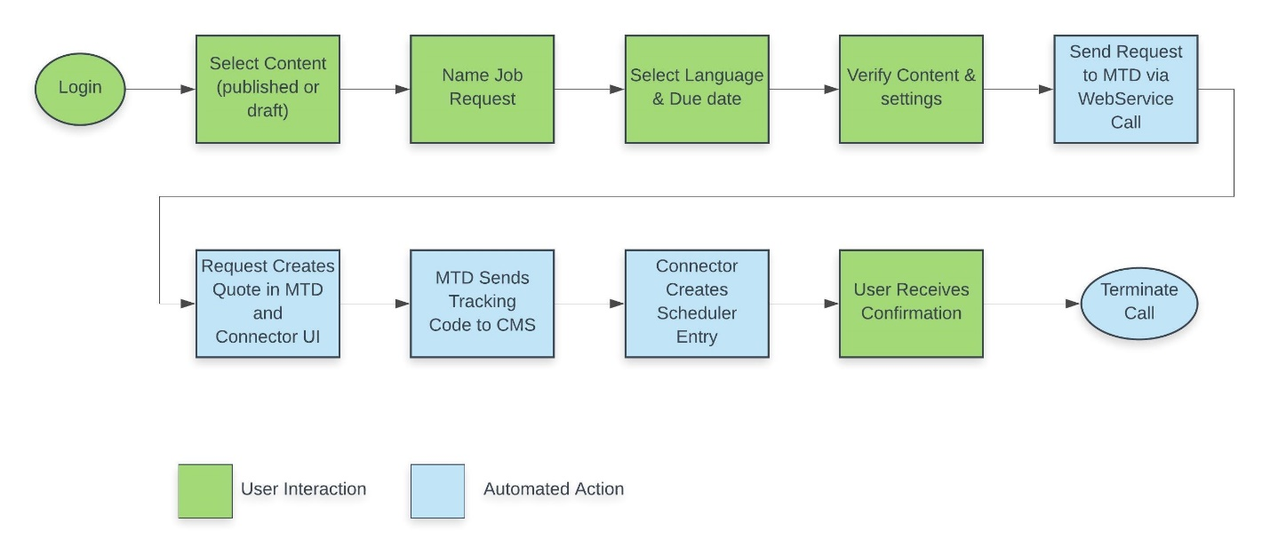

**Cancelling Jobs:**

Below is the workflow for cancelling jobs from the UI.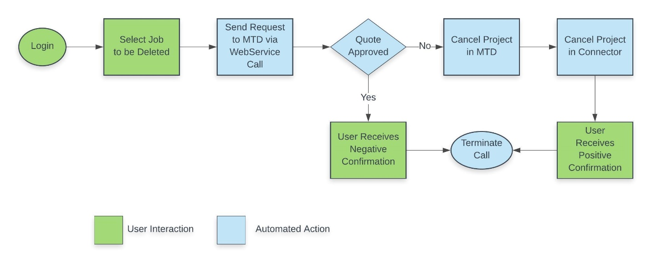

**Checking Status of Jobs:**

Below is the workflow for sending jobs from the UI.

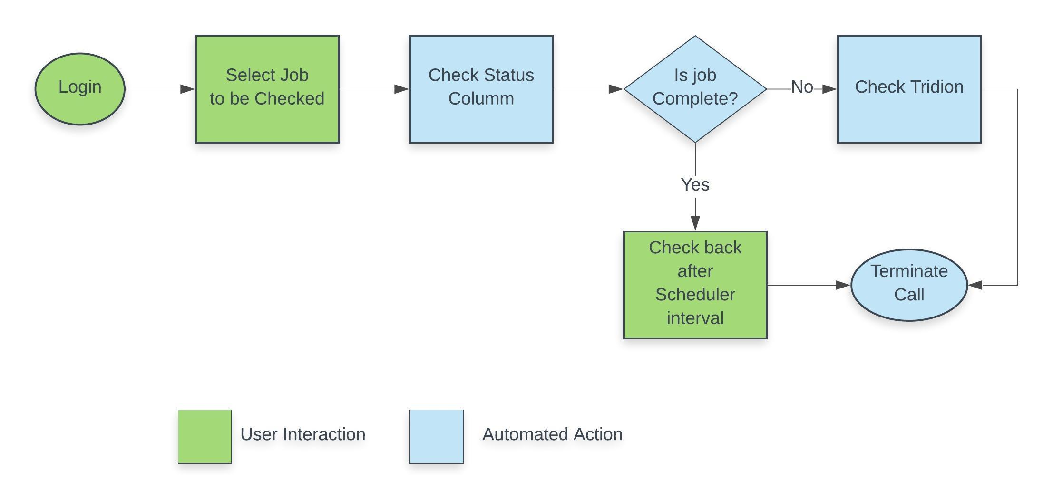

**Check Assets Submitted:**

Below is the workflow for checking the assets submitted as part of a specific job from the UI.

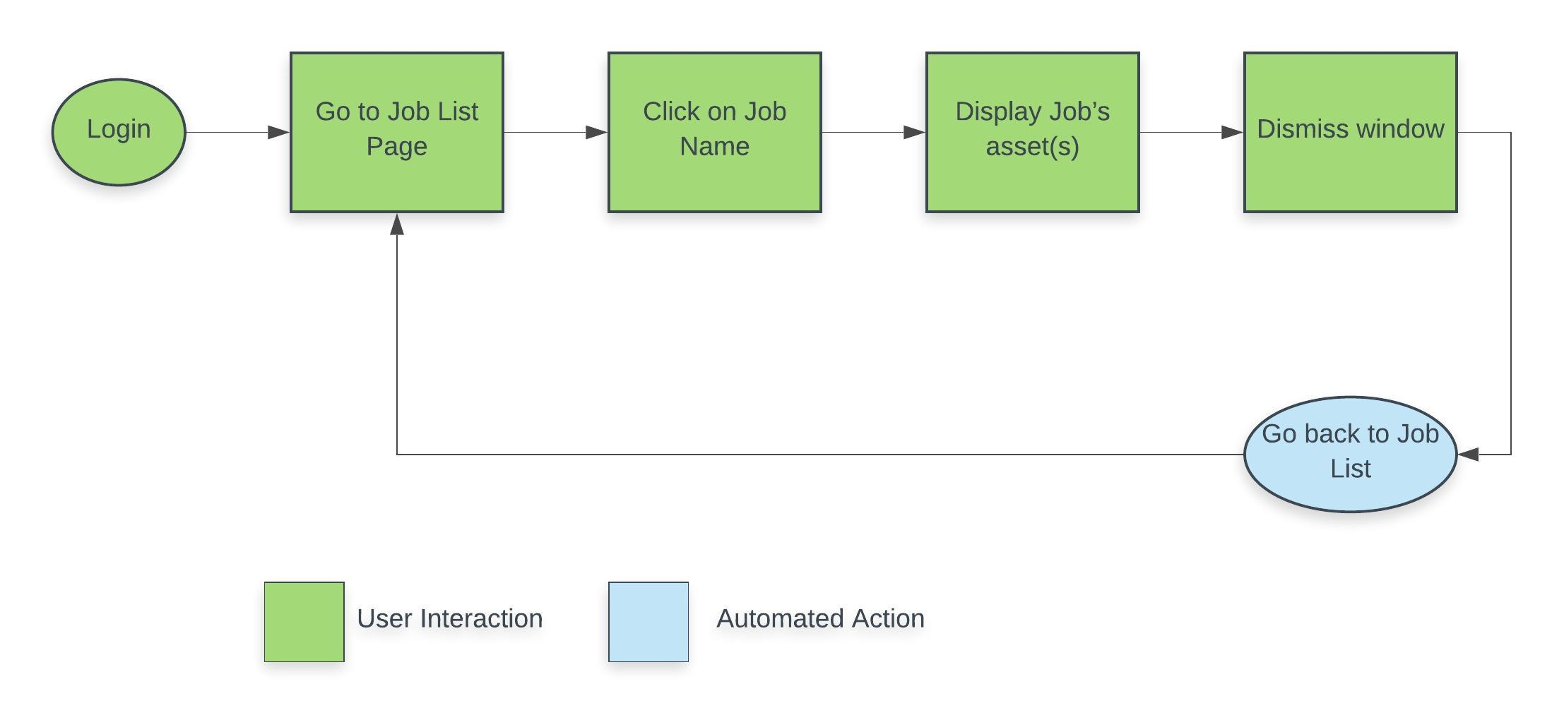

## Automated Cases

The end user will have mainly three interactions with the system, Send jobs, Cancel jobs and Check job progress.

**Check Status:**

Below is the workflow for checking job status from the Task Scheduler.

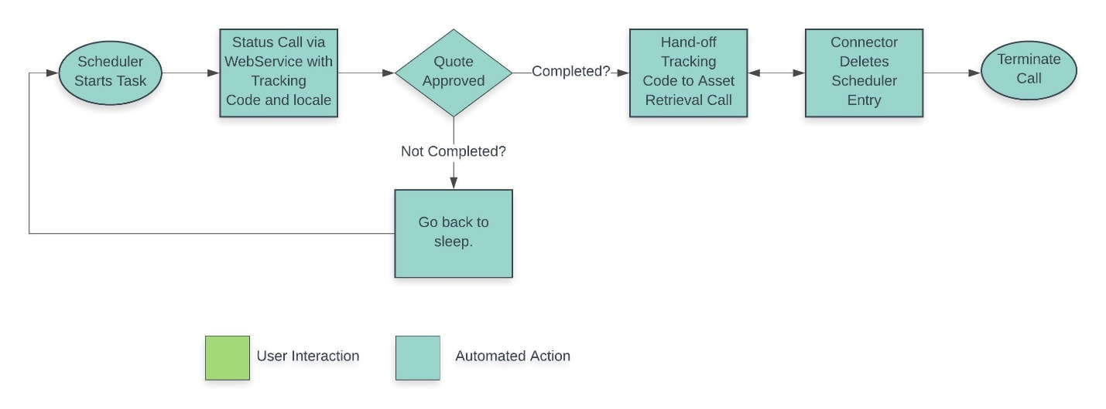

**Retrieve Assets:**

Below is the workflow for retrieving assets for completed projects.

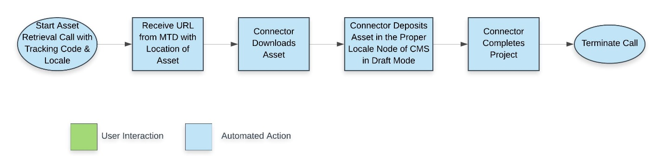

# **1.4.3 Logical View**

This section describes the architecturally significant parts of the design model.

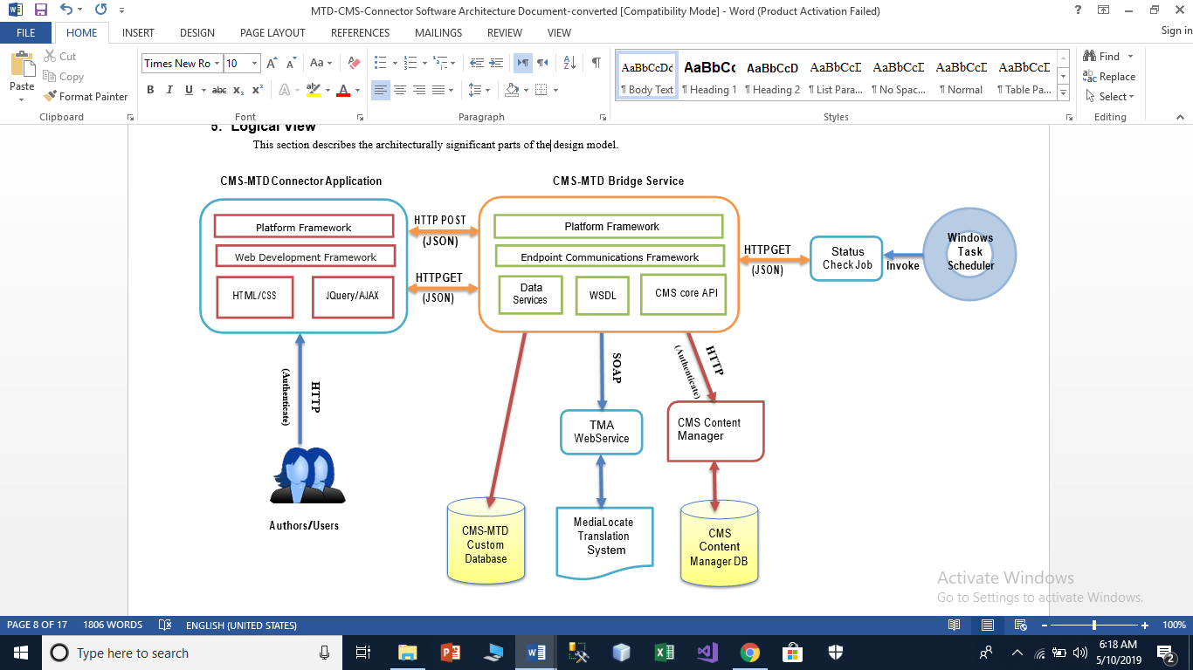

# **Process View**

A description of the process view of the architecture. Describes the tasks involved in the system's execution, their interactions and configurations.



Display CMS Content

Cancel Projects

Create Projects

Track Projects



**Scheduler**

Check Status

Asset Retrieval

Asset Packaging

Project Status

Workflow

Retrieve Assets

Send Assets

Update Status

Get/Update CMS Content



**Request**

**browser**

## 

## Connector App

**Track Project** – The Connector tracks the projects which have been sent for translation. As well as the project metadata: project name, due date, content reference, locales and project tracking code received from MTD.

**Create Projects** – The Connector UI facilitates the project creation process. It displays the content available for translation from the CMS. It allows for entering the project metadata and hands off to the bridge connector for content collection and transmittal.

**Display CMS content** – The Connector displays the content and structure of the CMS site for use with the project creation process. It also displays and handles changes to connector settings. Such as API key and TMA WebService URL.

**Cancel Projects** – The Connector UI makes provisions for canceling the project. Once the process is initiated, it hands off to the bridge connector for transmittal and cancellation acknowledgement.

However, if the project estimate has been approved in MTD, MTD will return an error and the project cannot be cancelled.

## Bridge Service

**Send Assets** – The Bridge handles packaging the content for translation from the CMS and sending it over to MTD. As part of the project creation and sending assets over to MTD, the Bridge will create a task scheduler entry for checking the status of the project in MTD at regular interval.

**Retrieve Assets** – The Bridge handles retrieval of the translated content from MTD.

**Get/Update CMS Content** – The Bridge handles extracting and importing of content from/to the CMS.

**Update Status** – The Bridge handles the project status update handoff from the scheduler and the update of the information in the Connector DB.

## 

## Scheduler

**Get Status** – The Scheduler will check, on a regular interval, for the status of the project in MTD. If the status returned shows Completed, the scheduler hands off to the bridge for asset retrieval.

## MTD

**Workflow Start** – MTD receives a create project web services call from the Bridge and kicks off a translation workflow within our system.

**Project Status** – MTD tracks the status of the project within our system. If the project has been completed, it returns a status_complete. Any other status can be ignored. The Bridge calls for project status for each locale separately.

Asset Packaging – MTD expects a zip package from the Bridge and it will send a zip package back. Each locale is packaged separately.

# 

# **Deployment View**

A description of the deployment view of the architecture describes the various physical nodes for the most typical platform configurations. Also describes the allocation of tasks (from the Process View) to the physical nodes.

This section is organized by physical network configuration.

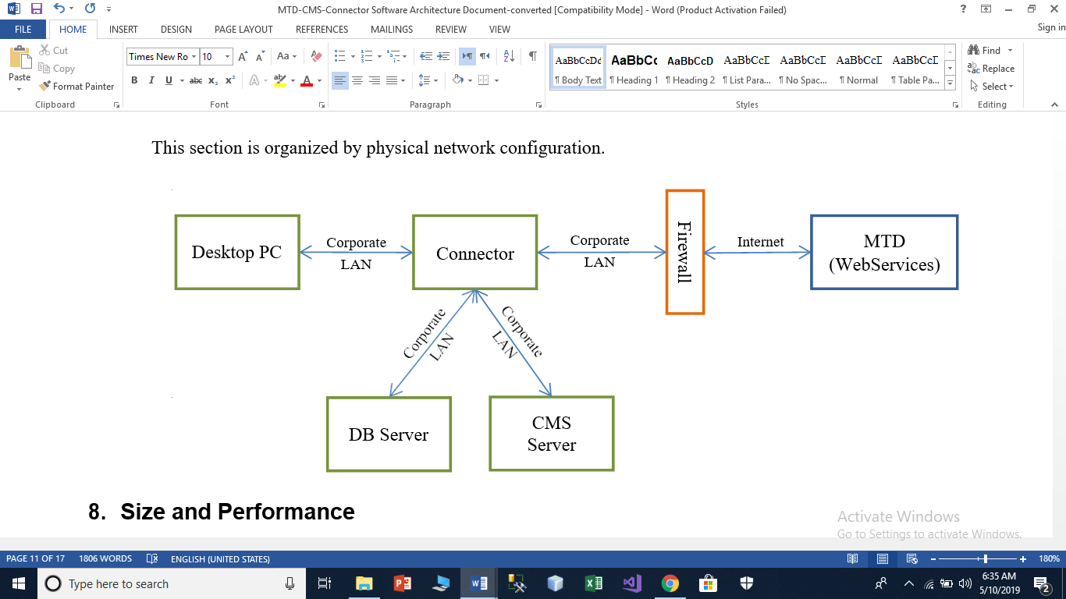

# 

# **Size and Performance**

The chosen software architecture should support any system size. Its performance is only limited by the infrastructure hosting the Connector App and Bridge Service.

The system shall support should support simultaneous users against the Connector App and central database at any given time.

Since the Connector App or Bridge Service uses a temp folder to store files being sent or received from MTD, there system should have adequate disk storage space.

The temp folder files should be deleted once they have been successfully sent to MTD or imported into the CMS after translation.

**1.5 Gantt Chart**

In planning the project,several steps are undertaken:

1. Identify the activities and tasks in the stage. Each activity must be identified to plan the completion date and allocate responsibilities among members of the project.This project has these activities:

* Recognition of need
* Feasibility study
* Analysis
* SRS
* Design
* Coding
* Testing
* Documentation
* Implementation

1. Determine the tasks for each activity and estimate completion times. Each activity is broken down into several tasks.
2. Determine the total estimated time for each activity.
3. Plot activities on the Gantt chart.

|  |  |  |  |  |  |
| --- | --- | --- | --- | --- | --- |
| Task | January | February | March | April | May |
| Requirement specification and Analysis |  |  |  |  |  |
| Design |  |  |  |  |  |
| Test Cases |  |  |  |  |  |
| Coding with unit testing |  |  |  |  |  |
| Testing |  |  |  |  |  |
| Documentation |  |  |  |  |  |

**CHAPTER 2: SYSTEM ANALYSIS**

* 1. **Requirement Analysis**
* The user/admin should be logged-in to perform his/her respective task.
* Administrative activity must be perform by the authenticated administrator.
* The Administrator can create new Translation Project using MediaLocate Translation Provider.
* The Administrator can create new Translation provider using MediaLocate Connector.
* User can add/delete multiple Translation Jobs.
* User can add assets/pages for translation (Translation Objects).
* User can start translation process.
* User can see Translation State and Status.
* Administrator can approve or reject a translation.
* Administrator can configure Proxy and Translation Configurations.
* Administrator can edit/delete Translation Project and Translation Provider.
* Content must be generated regarding the translation language when the administrator wishes.
* MediaLocate Connector should able to create XMLs from Translation Object, send to MediaLocate Connector and retrieve XMLs to their original format.

**2.2 User interface requirement**

* User Interface elements must be easy to understand.
* The user interface should be easy to learn. When the people use the user interface, they should know which element is used for which operations.
* The interface actions and elements should be consistent. When the required person presses any button, required actions should be done by the system.
* The screen layout and color of the user interface should be simple.
* Screen colors should not tire the eyes of users.
  1. **Risk Analysis**

Uncertainty, which is constantly present in our daily lives, frequently impacts our decisions and actions.  When we talk about risk, we normally mean the chance that some undesirable impact will occur.  Hence, we normally seek to avoid or minimize risk.  If there is a chance of rain, and we don't want to get wet, we may choose to stay indoors -- avoiding that risk -- or we may take an umbrella to minimize the impact of rain upon us. Uncertainty can impact our decisions and actions in desirable as well as undesirable ways.  In risk analysis we usually focus on what can go wrong -- the outcomes that represent loss or damage -- although an effective analysis will also help us understand what can go right as well.

A risk assessment involves evaluating existing physical and environmental security and controls, and assessing their adequacy relative to the potential threats of the organization. A business impact analysis involves identifying the critical business functions within the organization and determining the impact of not performing the business function beyond the maximum acceptable outage. Types of criteria that can be used to evaluate the impact include: customer service, internal operations, legal/statutory and financial.

A primary objective of business recovery planning is to protect the organization in the event that all or part of its operations and/or computer services is rendered unusable. Each functional area of the organization should be analyzed to determine the potential risk and impact related to various disaster threats.

Regardless of the prevention techniques employed, possible threats that could arise inside or outside the organization need to be assessed. Although the exact nature of potential disasters or their resulting consequences are difficult to determine, it is beneficial to perform a comprehensive risk assessment of all threats that can realistically occur to the organization. Regardless of the type of threat, the goals of business recovery planning are to ensure the safety of customers, employees and other personnel.  
Uncertainty can arise in several ways:

* If the quantity we'd like to know is a competing firm's planned product price, uncertainty arises from our **lack of knowledge**:  The price may be well known to that firm's employees, but it's unknown to us.
* If the quantity is market demand for products like ours, uncertainty arises from the **complexity of the process**:  Demand depends on economic factors, fashions and preferences, and our and other firms' actions -- and even if we knew all of these, we couldn't fully calculate their net impact on final demand.
* If the quantity is a material thickness in nanometers, uncertainty may arise from limits on our **ability to measure** this physical quantity.  We may also have limits on our **ability to control** fabrication of the material.

Many processes that we want to model -- from the failure rate of an electronic component to the behavior of a macromolecule -- have **inherent randomness** for all intents and purposes.

* 1. **Preliminary Investigation**

Preliminary system study is the first stage of system development life cycle. This is a brief investigation of the system under consideration and gives a clear picture of what actually the physical system is? In this stage the need of the system is evaluated. The initial system study involves the preparation of a ‘Project Overview’ which lists the Problem with the existing system, Objectives of the proposed system, Scope of the proposed System, Constraints, Expected benefits of the new system, etc. in the light of the user requirements. The main steps followed in this stage are:

* Problem identification and project initiation.
* Background analysis.
* Inference or findings (system proposal).
* Determine the size of the project.
* Assess costs and benefits of alternative approaches.
* Determine the technical feasibility of alternative approaches.
  1. **FEASIBILITY STUDY**

Feasibility Study which means to find out whether it is possible to implement the information system.If yes,we proceed to the next step otherwise we drop the idea to implement the Information System. Depending on the results of the initial investigation,the survey is expanded to a more detailed feasibility study.Feasibility study is a test of a system proposal according to its workability,impact on the organization ability to meet user needs,and effective use of resources.It focuses on three major questions:

1. What are the user’s demonstrable needs and how does a candidate system meet them?
2. What resources are available for given candidate systems? Is the problem worth solving?
3. What are the likely impacts of the candidate system on the organization?

**Types of Feasibility Study:-**

**Technical Feasibility:**

Technical Feasibility is concerned with specifying equipment and hardware and software that will successfully satisfy the user requirement.

The technical needs of the system may vary but might include:

* The facility to produce outputs in a given time.
* Response time under certain conditions.
* Ability to produce a certain volume of transaction at a particular speed.
* Facility to communicate data to distinct location.

In technical feasibility, the configuration of the system is given more importance than the actual make of the hardware.

Like in this system**“MediaLocate Connector”** following hardware and software requirements must be fulfilled:

* Content Management System (CMS): **AEM – Adobe Experience Manager**
* Interface Design: **AEM – Adobe Experience Manager, Jquery, JavaScript**
* Coding: **JAVA**

Specific software and hardware products can then be evaluated keeping in view with the logical needs. Hence it is technically feasible as all the software and hardware requirements are met by the organization.

**Economical Feasibility:**

Economic analysis or cost/benefit analysis is most frequently used technique for evaluating the effectiveness of a proposed system. It is procedure to determine the benefits and savings that are expected from the proposed system and compare them with costs. If the benefits outweigh the costs, a decision is taken to design and implement the system. Otherwise, further justification or alternative in the proposed system will have to be made if it is to have a chance of being approved. This is an on going effort that improves in accuracy at each phase of system life cycle.

A system so developed must be economically feasible so as to be beneficial for the organization The economical factor for **“MediaLocate Connector”** is feasible as all the resources used for its development lie within the budget estimated for its development.

**Operational Feasibility:**

Operational feasibility determines how the proposed system will fit in with the current operations and what will happen if any; process reconstruction or retraining of the specified user’s may be needed to implement the system. The evaluation must then determine the general attitude and skills of existing personnel and whether any such reconstruction of processes will be acceptable to the current users.

Operational Feasibility deals with the user interaction with the system and how the changes in the system may lead to the feasibility of the system. Will the system work accordingly and give fruitful results this is the main objective of this feasibility study.

The **“MediaLocate Connector”** is found to be feasible operationally because it is designed in such interactive manner that user need not to take any special training for operating the system. The User Guide is easy to understand and implement.

**Schedule Feasibility:**

This feasibility study deals with scheduling all the processes development so as to get the fully working and well developed system at the end without any loop holes in its processing. This study checks the whether all the processes are integrated and the work flow is as per the requirements.

The duration of time required for the project has been planned appropriately and it is the same as the duration of time expected by the client..

**CHAPTER 3: METHODOLOGY USED**

**3.1 Technologies Used**



* + 1. **Content Management System (CMS) – AEM (ADOBE EXPERIENCE MANAGER)**

Adobe Experience Manager (AEM), is a comprehensive content management solution for building websites, mobile apps and forms. And it makes it easy to manage your marketing content and assets.

Adobe Experience Manager brings your content management system (CMS) and digital asset management (DAM) together — in one place. With its native connection to Adobe Creative Cloud, you will be the customer experience management pro by getting content to market faster and creating the personalised experiences your customers expect.

Build lifetime value - deliver digital experiences over the lifetime of your customer that build brand loyalty and drive demand.

Be consistent across channels - deliver amazing content across websites and mobile, to in-store and beacons.

Get timely and personal - deliver and manage experiences that are responsive, relevant and social. Place the customer at the center.

**Why choose Adobe Experience Manager (AEM) for Web Project?**

1. **Adobe Experience Manager- AEM Manager / AEM CMS**

Adobe Experience Manager is the leading digital experience management solution that helps your business deliver compelling content across web, mobile, and the Internet of Things at the scale you need to build your brand and drive engagement. AEM manager is used as a Backbone structure for all types of App and website backed systems which are running on the cloud.

1. **Adobe AEM CMS Web Development**

AEM Mobile is the Mobile app development and management platform within AEM that allows you to create and deliver mobile apps for all devices and integrates your apps into your overall **marketing strategy from a single view**.

1. **AEM CMS Maintenance**

We also provide our clients with top notch **Maintenance and support system for AEM**. We also provide highly robust **AEM Web CMS Support to all of our clients**. Whenever you are facing a problem or having any trouble, our expert team will be available to help you.

1. **AEM Implementation**

Experience Manager formerly called Adobe CQ5/AEM implementation requires a technical team that understands the unique AEM development challenges a custom CMS poses, and a creative team experienced in component-driven design. We have an experienced team of technical and creative resources for your AEM CMS Implementation needs.

1. **AEM Content Management System**

AEM content management system (AEM CMS) is a software application and the type of set of related programs which are used to create and manage the digital Website content management system.

**AEM Development (Web CMS Development) Services:**

**AEM Web Development Services are as below:**

* AEM's browser-based editing means you may login and edit your site anywhere with your Admin ID
* Integration features for top social platforms makes it easy to connect with your audience
* Easy to use web form and email form templates
* Automatic and related link navigation
* Easy to create news and events lists

**AEM Implementation & AEM Development**

There are lots of AEM development's companies, which will offer you cq5/AEM CMS implementation along with expertise in AEM Manager. But choosing the right one always matters.

**AEM Integration**

We are working with many clients and helping them to integrate AEM Manager with their systems. We provide all type of AEM services and the technical AEM support which is useful in the AEM Integration. We are giving them an opportunity to grow their business and speed up their development process. We also provide AEM Tool integration with the existing CRM systems so that you can maintain/enhance your relationship with your customer.

**AEM CMS Migration and Upgrade**

With the help AEM CQ/CQ5 Tool migration services, you will be easily able to migrate anything to Adobe Experience Manager. Experts handle all work properly and without any hassle.

**Adobe CMS - AEM Support & Maintenance**

**Below are the some important AEM Support and AEM Maintenance services:**

* Unlimited 24/7 global AEM support during your AEM maintenance period (by email and phone).
* Experienced Adobe AEM Developers Team
* Trouble Shooting
* Code Optimization
* Pro-active maintenance.
* Security Enhancement
* Patch fixing
* Version Upgrades
* Premium AEM support, AEM consulting and AEM training to ensure that all of your projects run smoothly and easily.

**3.1.2 JAVA** 

Java is a general-purpose programming language that is class-based, object-oriented, and designed to have as few implementation dependencies as possible. It is intended to let application developers "write once, run anywhere" (WORA), meaning that compiled Java code can run on all platforms that support Java without the need for recompilation. Java applications are typically compiled to "bytecode" that can run on any Java virtual machine (JVM) regardless of the underlying computer architecture. The syntax of Java is similar to C and C++, but it has fewer low-level facilities than either of them. As of 2018, Java was one of the most popular programming languages in use according to GitHub,particularly for client-server web applications, with a reported 9 million developers.

**3.1.3 JSP – JavaServer Pages**

JavaServer Pages (JSP) is a technology that helps software developers create dynamically generated web pages based on HTML, XML, or other document types. Released in 1999 by Sun Microsystems,JSP is similar to PHP and ASP, but it uses the Java programming language.

To deploy and run JavaServer Pages, a compatible web server with a servlet container, such as Apache Tomcat or Jetty, is required.

**The JSP Model 2 architecture:**

Architecturally, JSP may be viewed as a high-level abstraction of Java servlets. JSPs are translated into servlets at runtime, therefore JSP is a Servlet; each JSP servlet is cached and re-used until the original JSP is modified.

JSP can be used independently or as the view component of a server-side model–view–controller design, normally with JavaBeans as the model and Java servlets (or a framework such as Apache Struts) as the controller. This is a type of Model 2 architecture.

JSP allows Java code and certain predefined actions to be interleaved with static web markup content, such as HTML, with the resulting page being compiled and executed on the server to deliver a document. The compiled pages, as well as any dependent Java libraries, contain Java bytecode rather than machine code. Like any other Java program, they must be executed within a Java virtual machine (JVM) that interacts with the server's host operating system to provide an abstract, platform-neutral environment.

JSPs are usually used to deliver HTML and XML documents, but through the use of OutputStream, they can deliver other types of data as well.

The Web container creates JSP implicit objects like request, response, session, application, config, page, pageContext, out and exception. JSP Engine creates these objects during translation phase.

**3.1.4 JQuery**

jQuery is a fast, small, and feature-rich JavaScript library. It makes things like HTML document traversal and manipulation, event handling, animation, and Ajax much simpler with an easy-to-use API that works across a multitude of browsers. With a combination of versatility and extensibility, jQuery has changed the way that millions of people write JavaScript.

**3.2 Software and Hardware Requirement Specification**

The system should have an WebBrowser capable enough to support Javascript/jquery. The detailed requirements are given in the next section which specifies the minimal requirement to run the product.

**Software Requirements:**

**Server**

* + Browser : Chrome version 49 and above/ Firefox
  + Content Management System : Adobe Experience Manager (AEM)
  + Operating System : Linux version 3 or above/

Windows XP or above/ MacOS 10.0 or above

**User**

* + Browser : Chrome version 49 and above/ Firefox
  + Content Management System : Adobe Experience Manager (AEM)
  + Operating System : Linux version 3 or above/

Windows XP or above/ MacOS 10.0 or above

**Developer**

* Software : 1. AEM version : AEM 6.1

2. Code Management Tool : GIT

* + Browser : Chrome version 49 and above/ Firefox
  + Content Management System : Adobe Experience Manager (AEM)
* Operating System : UBUNTU 5
* Documentation tool : MS Word, MS Power -point

**Hardware Specifications:**

**Server**

* Processor : CORE i5 or above
* RAM : 8 GB
* HDD : 500 GB
* Display : 1024 x 768 High color-32-bit

**User**

* Processor : CORE i3 or above
* RAM : 8 GB
* HDD : 100 GB
* Display : 240 * 320 px or Higher

**Developer**

* Processor : CORE i5 or above
* RAM : 16 GB
* HDD : 100 GB
* Display : 1024 x 768 High color-32-bit

**CHAPTER 4: SYSTEM DESIGN**

**4.1 System Life Cycle**

To solve actual problems in an industry setting, software engineer or a team of Engineers must incorporate a development strategy that encompasses the process, methods, and tools layers. This strategy is often referred to as a process model or a software engineering paradigm.

A process model or a software engineering is chosen based on the nature of the project and application, the methods and tools to be used, and the controls and deliverables that are required.

In this project, **Iterative Water Fall Model** has been used. Steps involved are as follows:

**ITERATIVE WATER FALL MODEL**

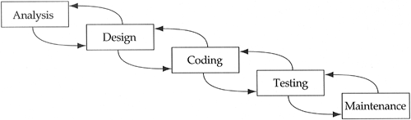

Iterative process starts with a simple implementation of a subset of the software requirements and iteratively enhances the evolving versions until the full system is implemented. At each iteration, design modifications are made and new functional capabilities are added. The basic idea behind this method is to develop a system through repeated cycles (iterative) and in smaller portions at a time (incremental).

Iterative and Incremental development is a combination of both iterative design or iterative method and incremental build model for development. "During software development, more than one iteration of the software development cycle may be in progress at the same time." and "This process may be described as an "evolutionary acquisition" or "incremental build" approach."

In incremental model the whole requirement is divided into various builds. During each iteration, the development module goes through the requirements, design, implementation and testing phases. Each subsequent release of the module adds function to the previous release. The process continues till the complete system is ready as per the requirement.

The key to successful use of an iterative software development lifecycle is rigorous validation of requirements, and verification & testing of each version of the software against those requirements within each cycle of the model. As the software evolves through successive cycles, tests have to be repeated and extended to verify each version of the software.

**4.2 System designing approaches:**

**Top – Down designing***:*

The top - down designing approach starts with major components of the system. It is a stepwise refinement which starts from an abstract design, in each steps the design is refined two or more concrete levels until we reach a level where no – more refinement is possible or not needed.

**Bottom – Up designing*:***

In bottom – up designing the most basic and primitive components are designed first, and we proceed to higher level components. We work with layers of abstractions and abstraction are implemented until the stage is reached where the operations supported by the layer is complete.

**CHAPTER 5: INPUT AND OUTPUT SPECIFICATIONS**

### 1. Package Manager

1) **Select Packages tool :** Access the Package Manager by Navigating to *http://{host}:{port}/crx/packmgr/index.jsp*.

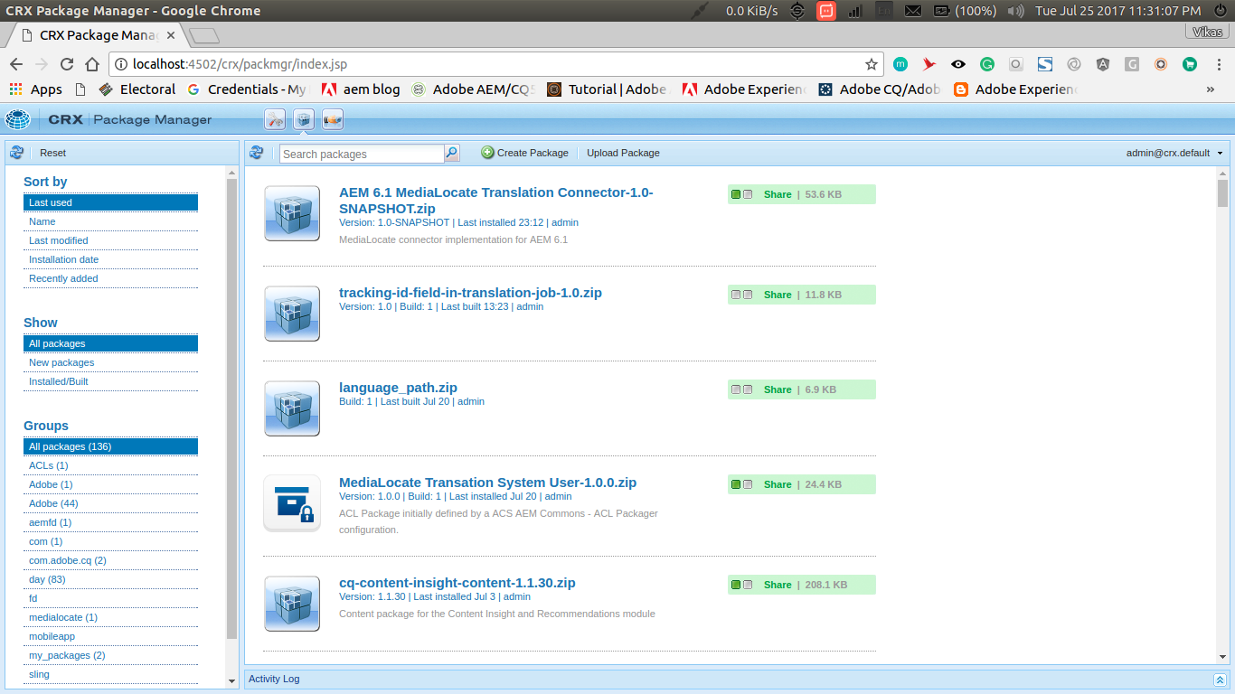

2) **Open up upload package dialog :** Click on **Upload Package** button in the CRX package Manager.

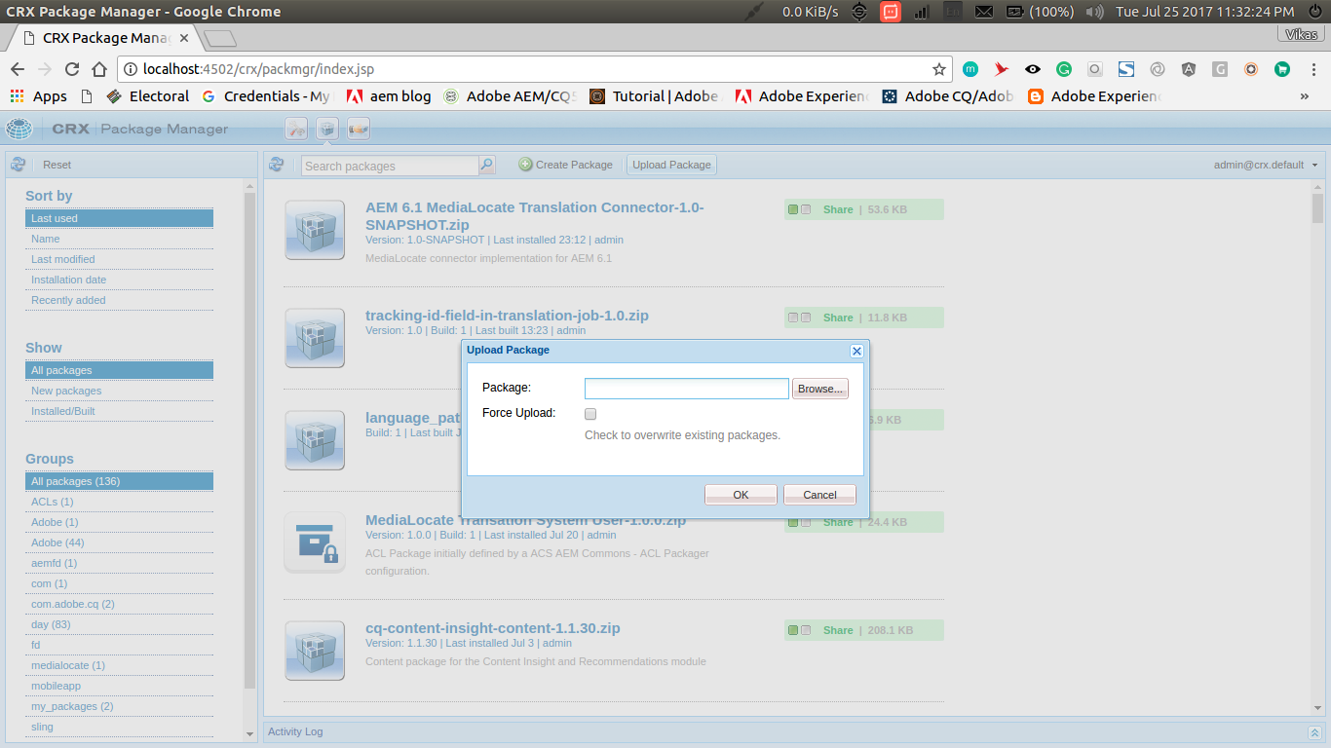

3) **Upload package :** Browse to the location where the MTD Connector Installation Package is located and click the “OK” button to upload the package.

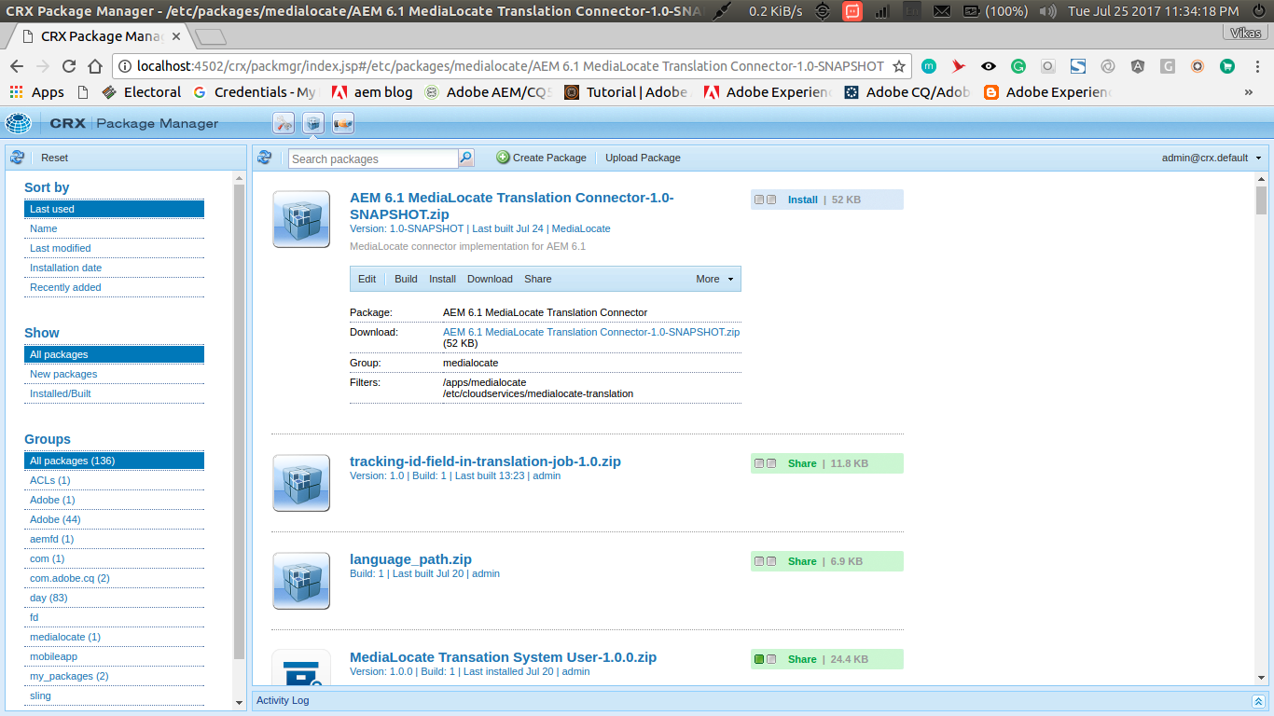

4) **Installing the Installation Package :** Click the **Install** button.

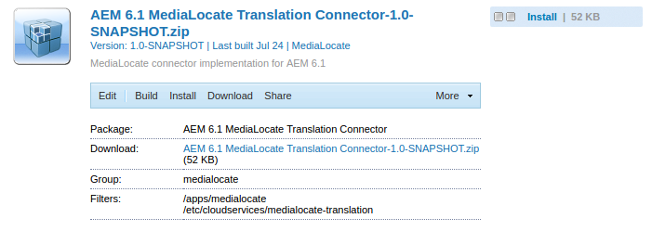

### 

### 

### 2. Configuring System User

1) **Open User admin console :** Access the User admin console by Navigating to *http://{host}:{port}/useradmin*.

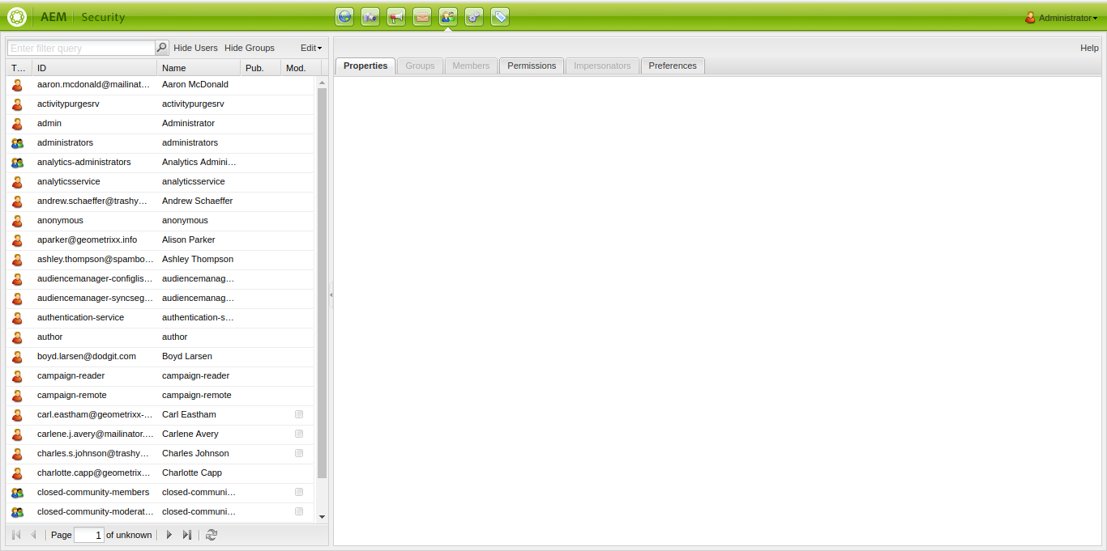

2) **Search system user :** Search for ***translation-job-service*** user in the search box provided on top left side. Double click on the translation-job-service user to configure it.

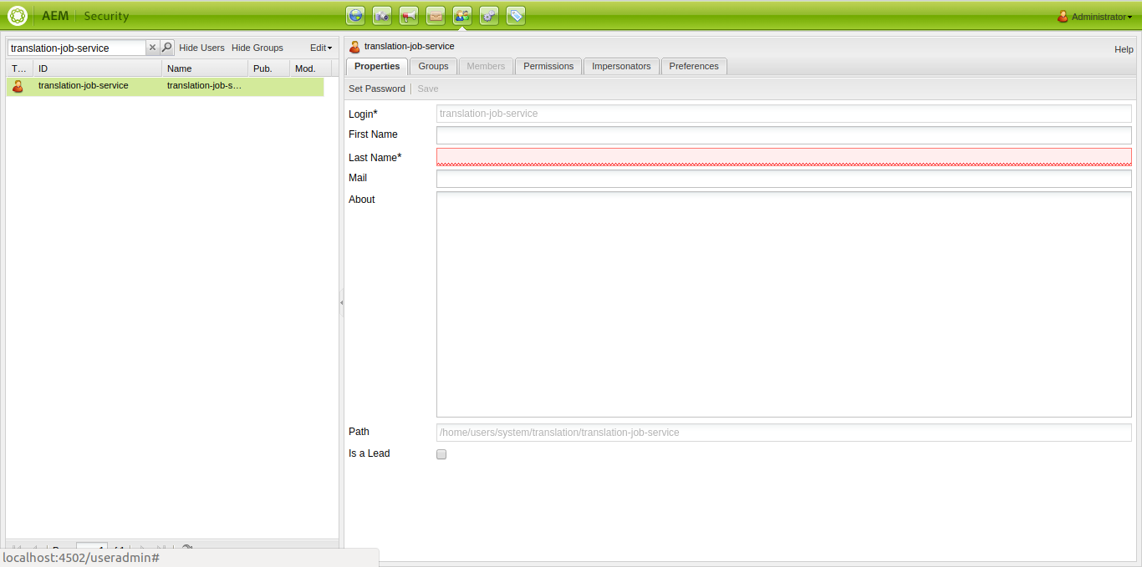

3) **Give Permissions :**  Select the **Permissions** tab and check the checkbox under the *Read* column for ***etc*** *and* ***content****.*

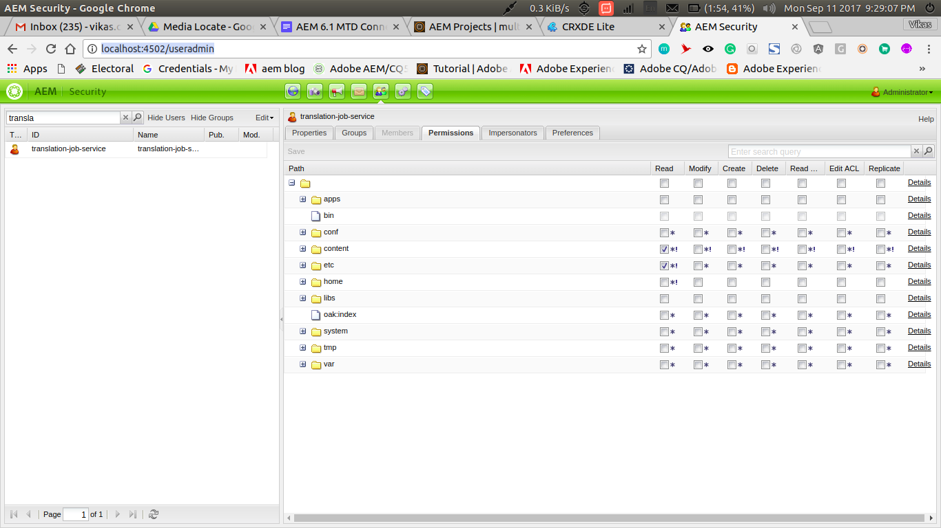

3) **Save Configurations :** Click the save button in the top left corner of right panel.

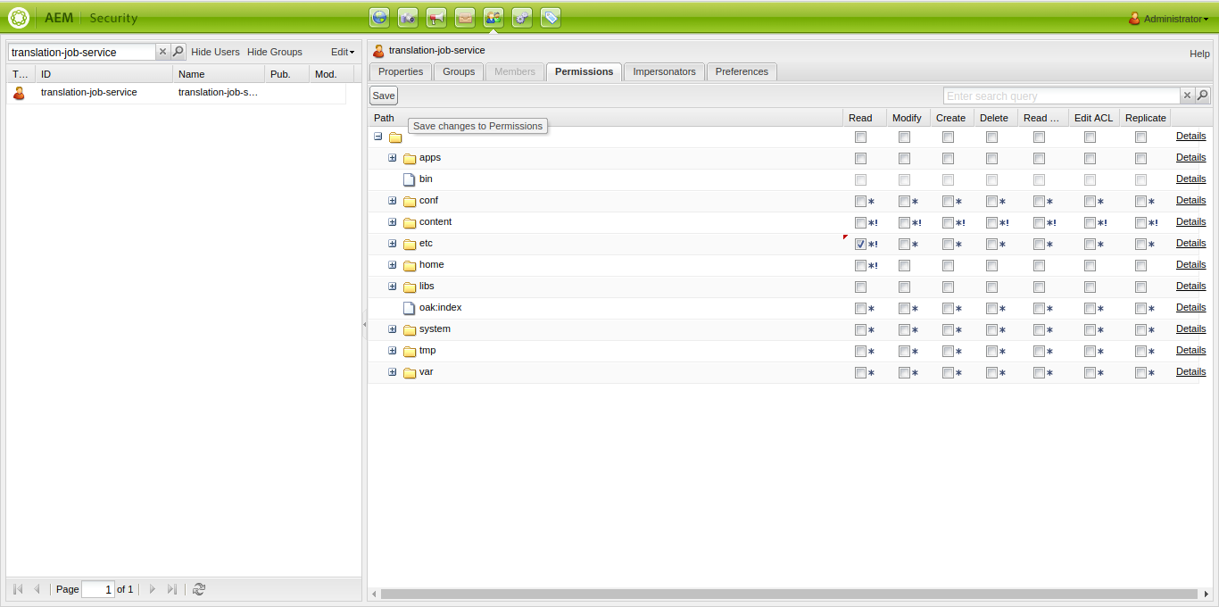

### 3. OSGI Configuration

1. Access the Configuration tab of the Web Console by either:

* Opening the Web Console from the link on the Tool menu.

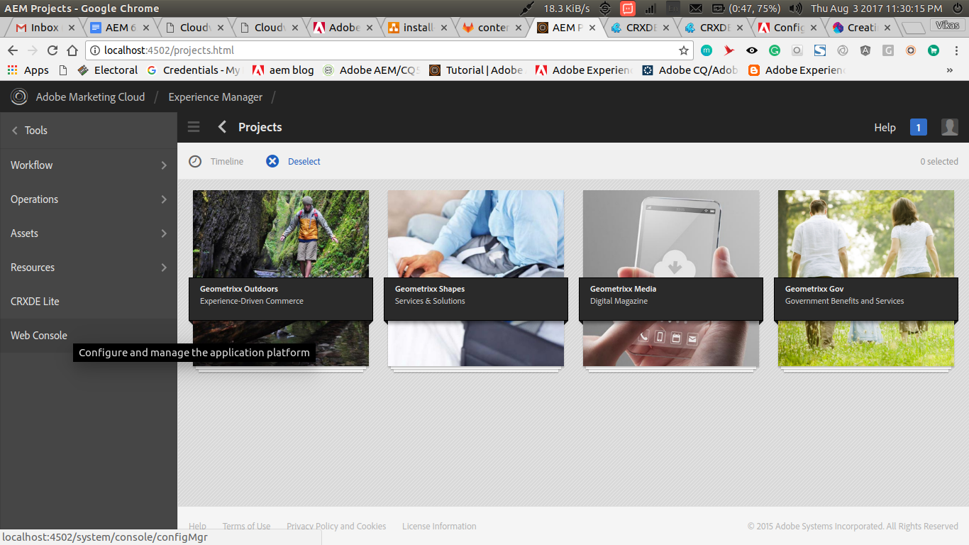

* The direct URL, *http://{host}:{port}/system/console/configMgr*

A list will be shown.

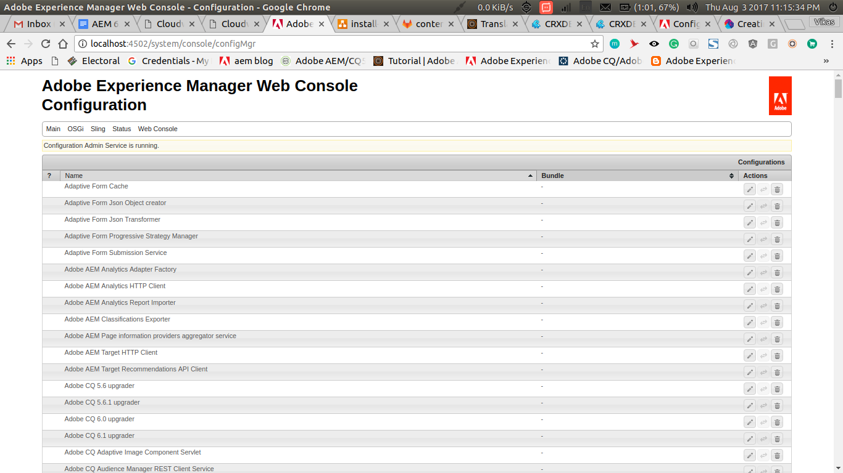

2) Select the MediaLocate Translation Configuration bundle to configure by either:

* clicking on the Edit icon for that bundle
* clicking on the Name of the bundle

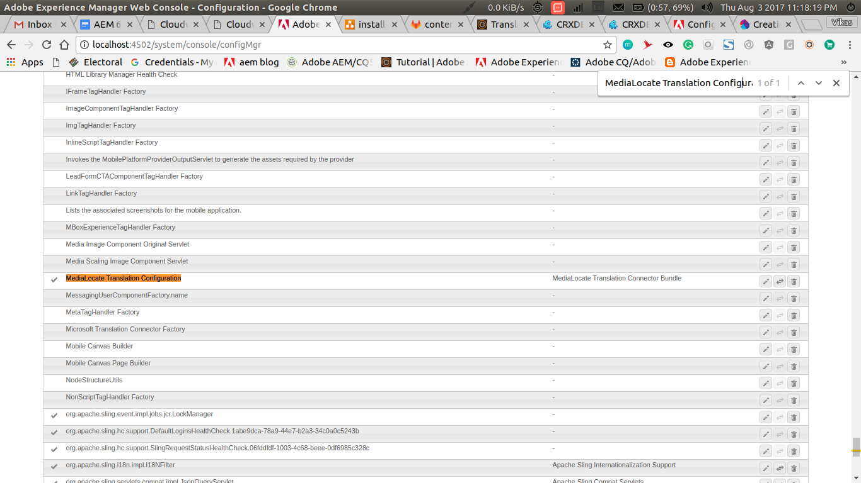

3) A dialog will open with several fields as follows :

* **Temp Folder Path :** The folder path to store temporary files generated during translation, defaults to {path-to-crx-quickstart}/temp.
* **Supported MIME Types :** Used to configure the list of mime types supported by MTD.
* **Maximum time to retry :** Maximum time in minutes to retry for project creation in case of server unavailability.
* **Connection Timeout** : Maximum time in milliseconds to create a connection with MTD servers, defaults to 60000 ms.
* **Request Timeout :** Maximum time in milliseconds to wait for response from MTD servers, defaults to 10000 ms.
* **Use AEM Languages :** Used to configure the list of language shown in source and target dropdown in translation project creation screen. The default value is set to true, which means that AEM’s OOTB languages would be shown. In case only MTD languages are required to be shown, checkbox should be unchecked.

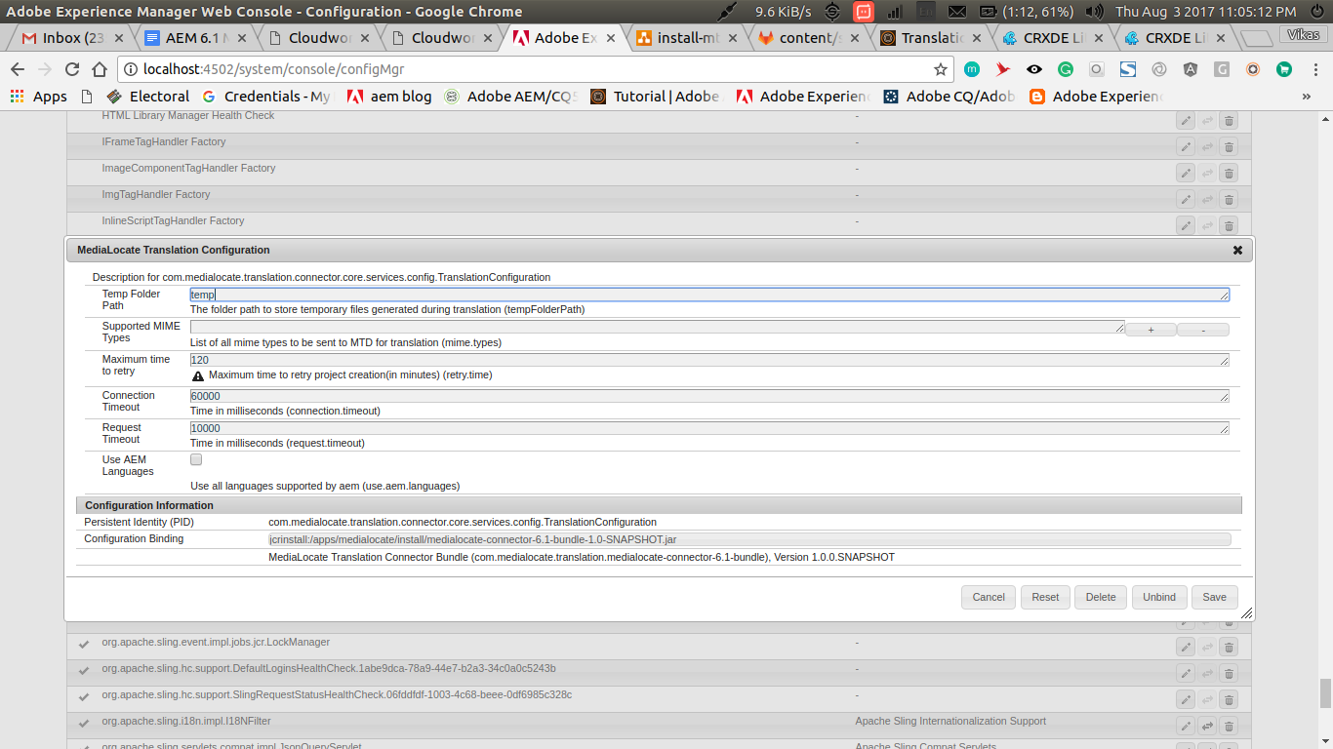

**Configure Proxy:**

1) Go to *http://{host}:{port}/system/console/configMgr*

2) Select the MediaLocate Proxy Configuration

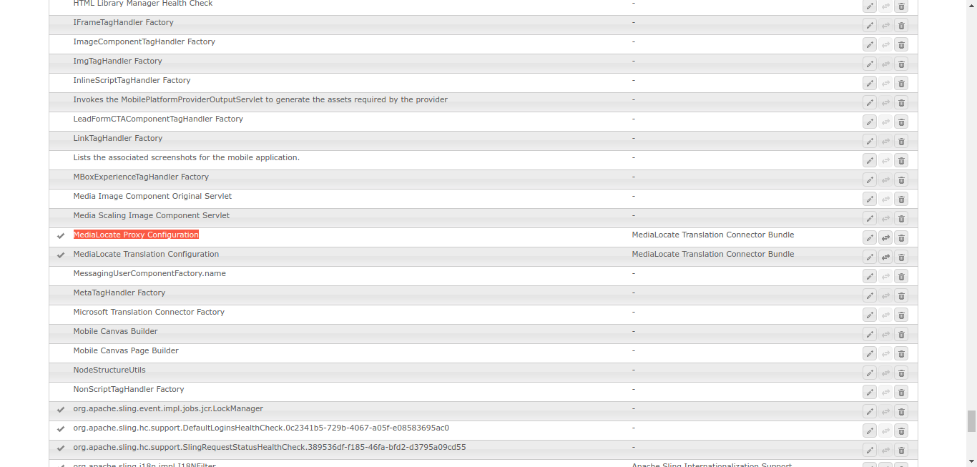

2) A dialog will open with several fields as follows :

* **Enable Proxy :** Enable this to use a proxy while connecting to MediaLocate web service. The default value is set to false.
* **Proxy Type:** There are 3 options - Custom, Apache and Day Commons
  + Custom : If it isn’t known how proxy is being set on AEM server, then proxy configurations which are entered in the existing configuration box is preferred and set
  + Apache - In case proxy configurations are set in ‘Apache HTTP Components Proxy Configuration’ component, then the values entered in this component are set
  + Day Commons - In case proxy configurations are set in ‘Day Commons HTTP Client 3.1’, then the values entered in this component are set
* **Proxy Host**: Host name or IP address of the Proxy server
* **Proxy Port**: Port of Proxy server
* **Proxy User**: In case authentication is enabled, then User can be specified here
* **Proxy Password**: In case authentication is enabled, then Password can be specified here

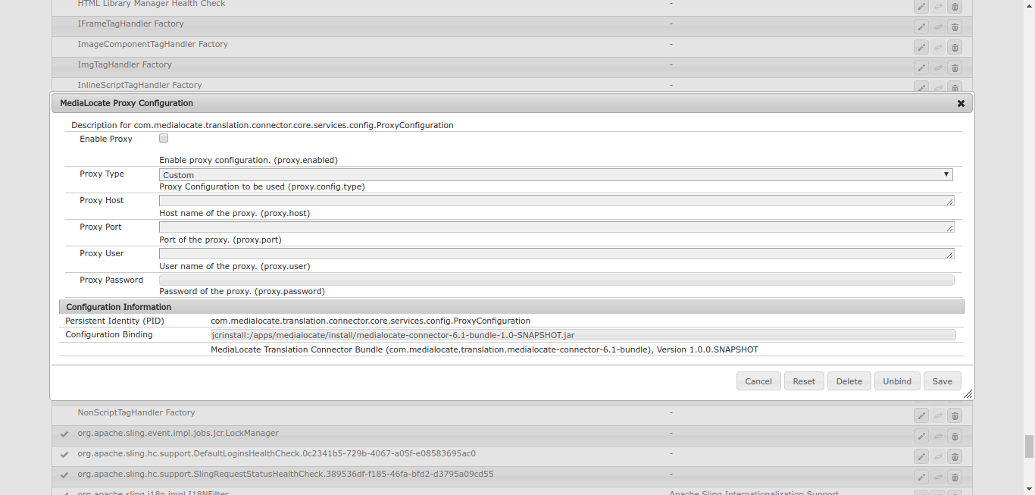

### 

### Translation Rule File

Translation rule file is a XML file which can be accessed from aem's CRX at *http://{host}:{port}/crx/de/index.jsp#/etc/workflow/models/translation/translation_rules.xml*. This is used to identify the content to translate.

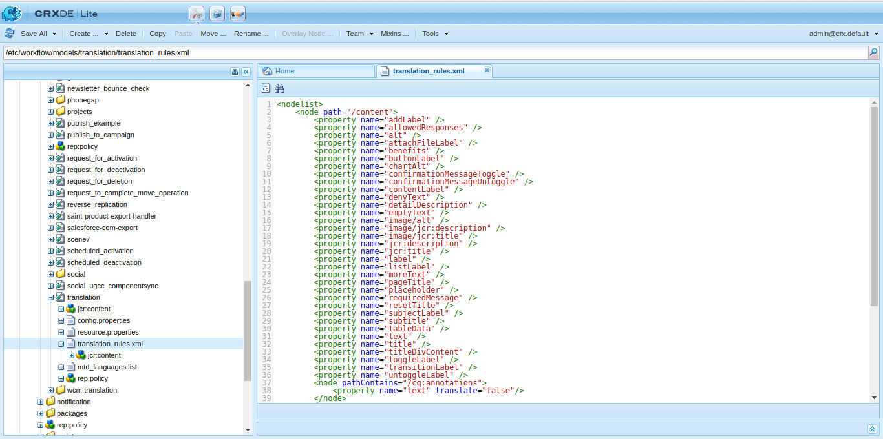

The translation_rules.xml file consists of a 'nodelist' element with several child 'node' elements.

* **nodelist :** root element
* **node :** rule that translates the content

**For example**:

<**nodelist**>

**...**

<**node** path="/content">

<**property** name="title"/>

<**property** name="subtitle" [translate="false"]/>

</**node**>

**...**

</**nodelist**>

* The path attribute contains the path to the root node of the branch to which the rules apply. The rule also applies to the descendants of the node.
* Child property elements identify the node properties to translate
  + The name attribute contains the property name.
  + The optional 'translate' attribute is set to false if the property is not to be translated. By default the value is true.

**To translate properties for a specific resource type only:**

<**node** path="/content">

<**property** name="text"/>

<**node** **resourceType**="mediaLocate/components/customComponent">

<**property** name="customText"/>

<**property** name="customDescription"/>

</**node**>

</**node**>

* The resourceType attribute contains the path that resolves to the component that implements the resource type.

[Read More](https://docs.adobe.com/docs/en/aem/6-1/administer/sites/translation/tc-rules.html)

1. MTD Language List file

This file contains the list of Languages supported by MediaLocate. It can be accessed from aem's CRX at *http://{host}:{port}/crx/de/index.jsp#/etc/workflow/models/translation/mtd_languages.list.*

Each row contains the language-code and language-label separated by a ‘**:**’. If language-label is not defined then the language-code will be used as language-label.

This file contains entries in the following format :

**Language Code : Language Title**

To add a new language say, Spanish(es-hn) we can add the following entry in this file

es-hn:Honduras - Spanish

### 6. MTD Cloud Configuration

1. **Configuration page**

The configuration page can be accessed from AEM’s misc admin console at: *http://{host}:{port}/miscadmin#/etc/cloudservices/medialocate-translation*

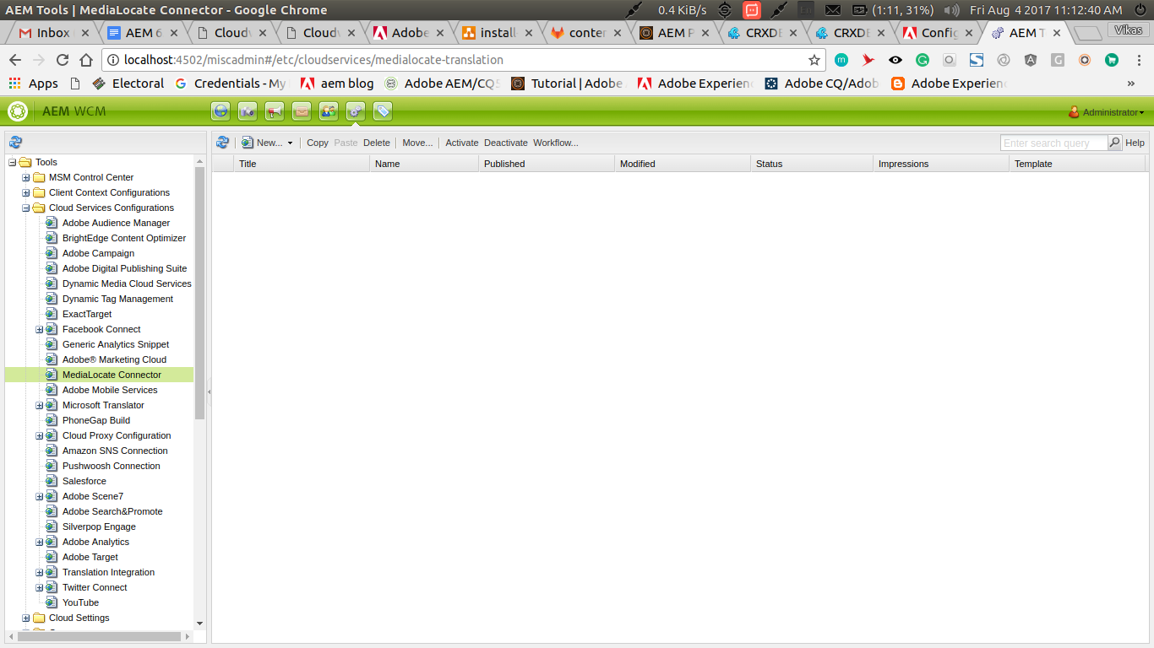

**2) Open up MediaLocate Connector configuration page**

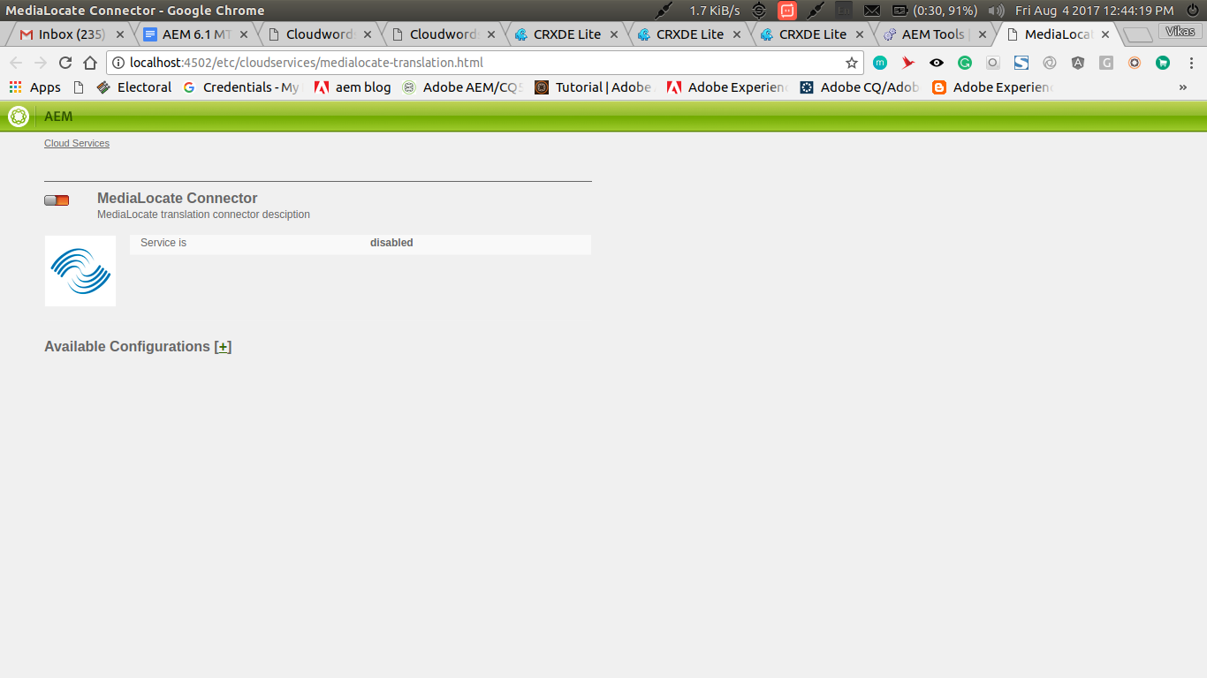

**3) Add a new MTD configuration** Click the “+” button to add a new configuration.

Add Title for the configuration, then click create to add a new configuration.  
  
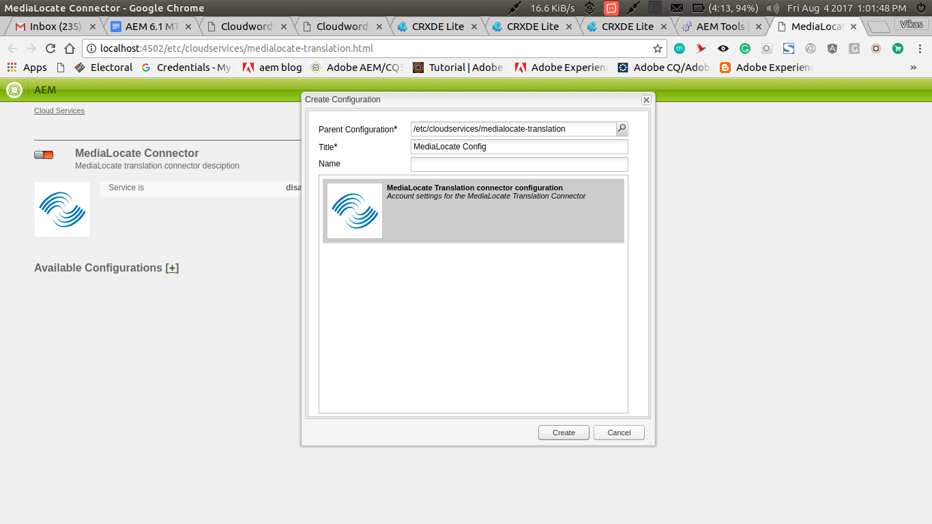

**4) Configure the new MTD configuration created**

Add server url and MTD_GUID key in the dialog, then click Ok

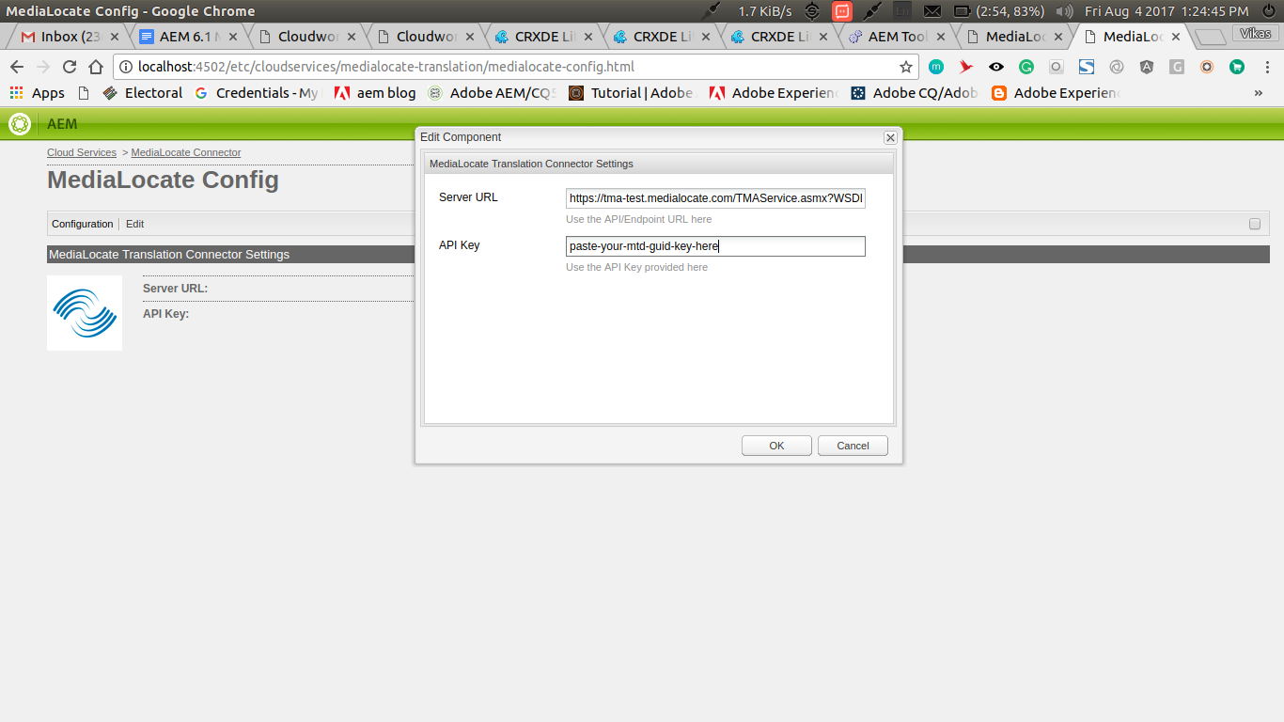

**5) MTD connector configuration successful**

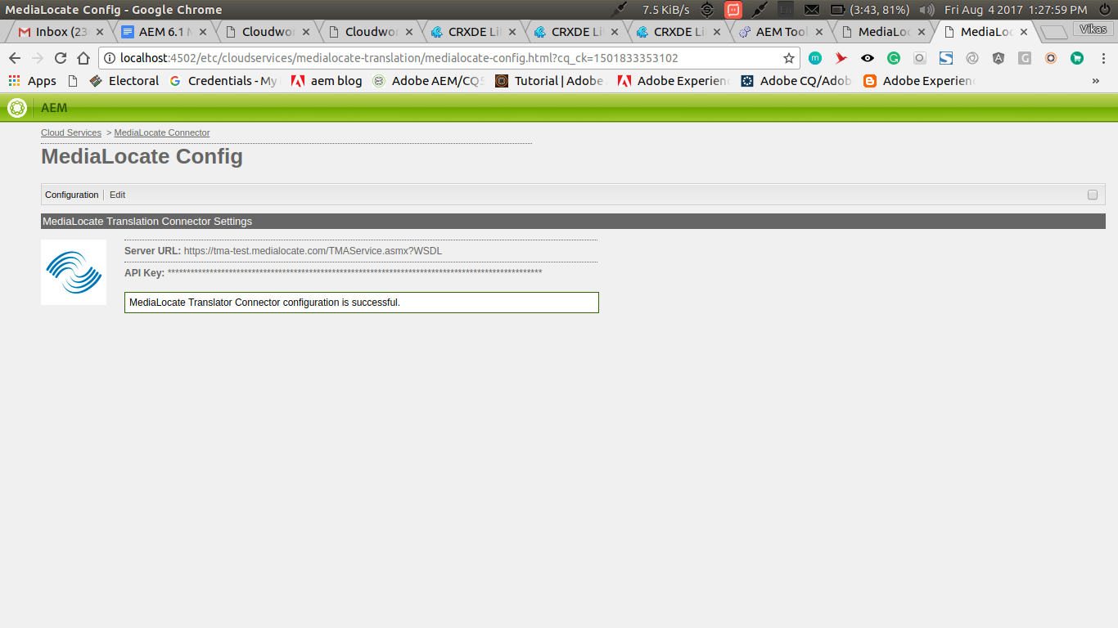

## User Steps

### Using Project Creation Wizard to add source files for translation

#### Project Creation

1. **Projects Console :**The projects console can be accessed at: *http://{host}:{port}/projects.html*In Projects, tap/click Create to open the Create Project wizard.

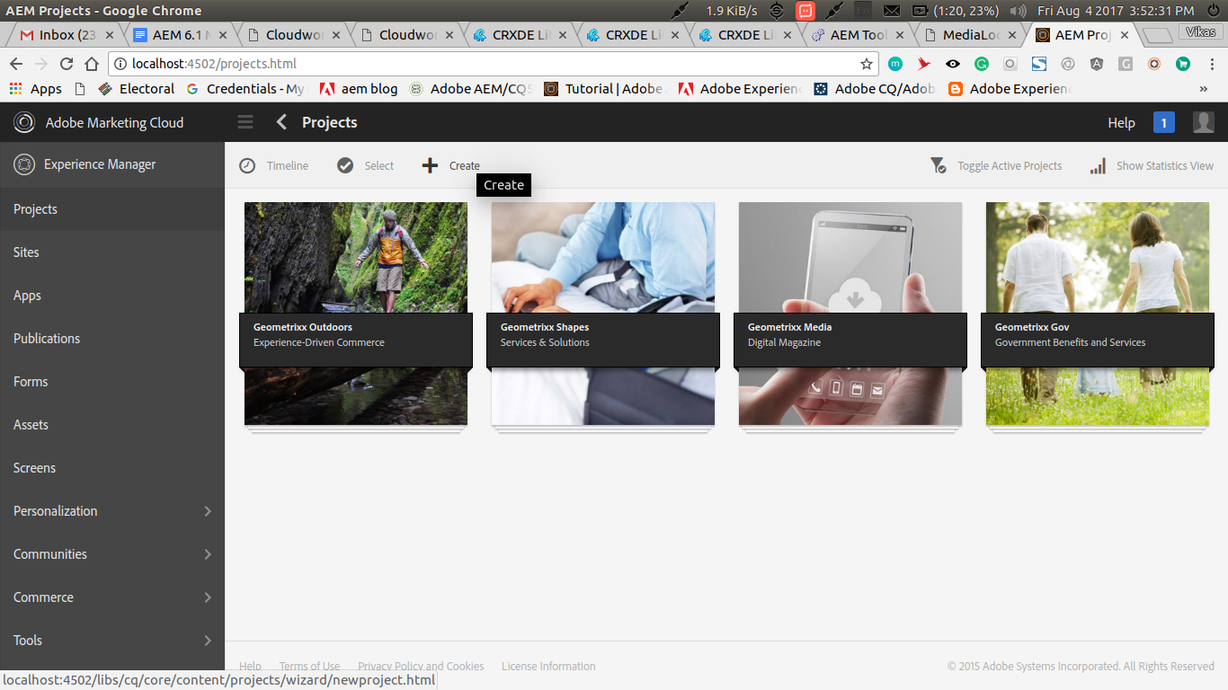

1. **Project Creation Page :**Select Translation Project template and click Next.

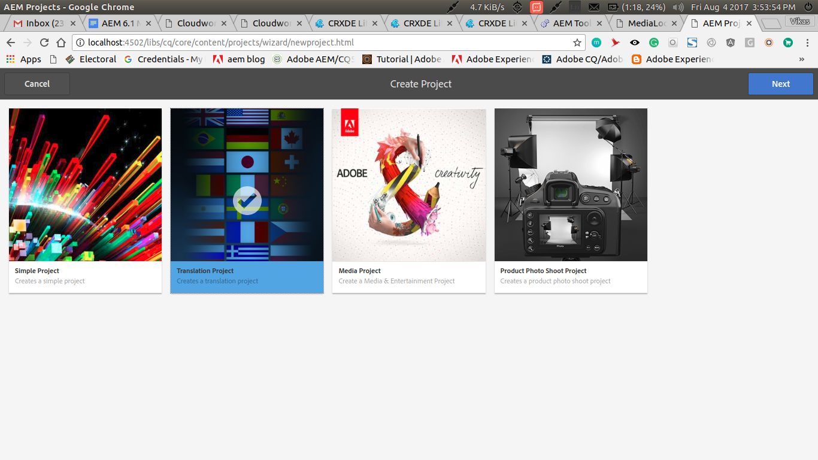

1. **Translation Project Configuration :**Define the Title and Description and add a Thumbnail image if required. You also add due date. In addition, click Advanced to add a name used in the URL.

* Fill out project “basic” config page

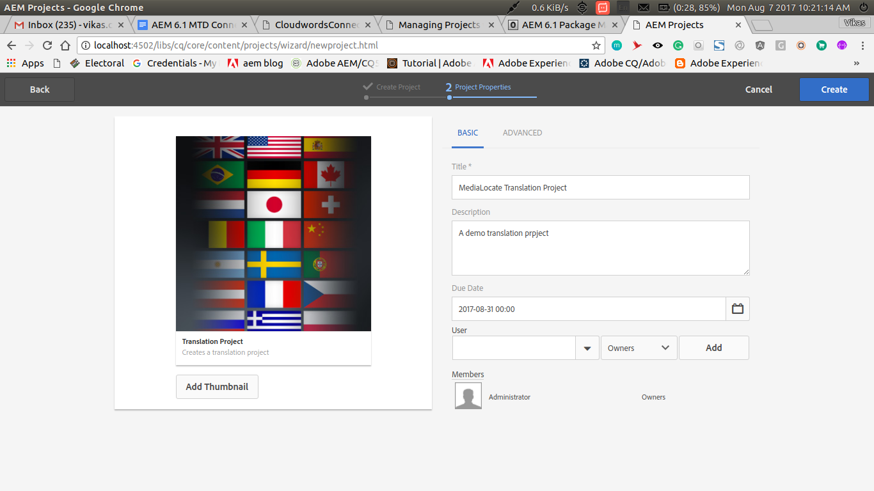

* Fill out project “advanced” config page, and then click “create”.
  + **Name :** Name used in the URL.
  + **Source Language :** Language of the content being translated.
  + **Target Language :** Language in which the content is to be translated.
  + **Translation Method :** Type of translation. Choose Human Translation.
  + **Translation Provider :** List of available translation service provider.
  + **Cloud Config :** Cloud configuration associated with translation provider.  
    Choose the Cloud configuration created in above steps here.

Tap/click Create to create the project.

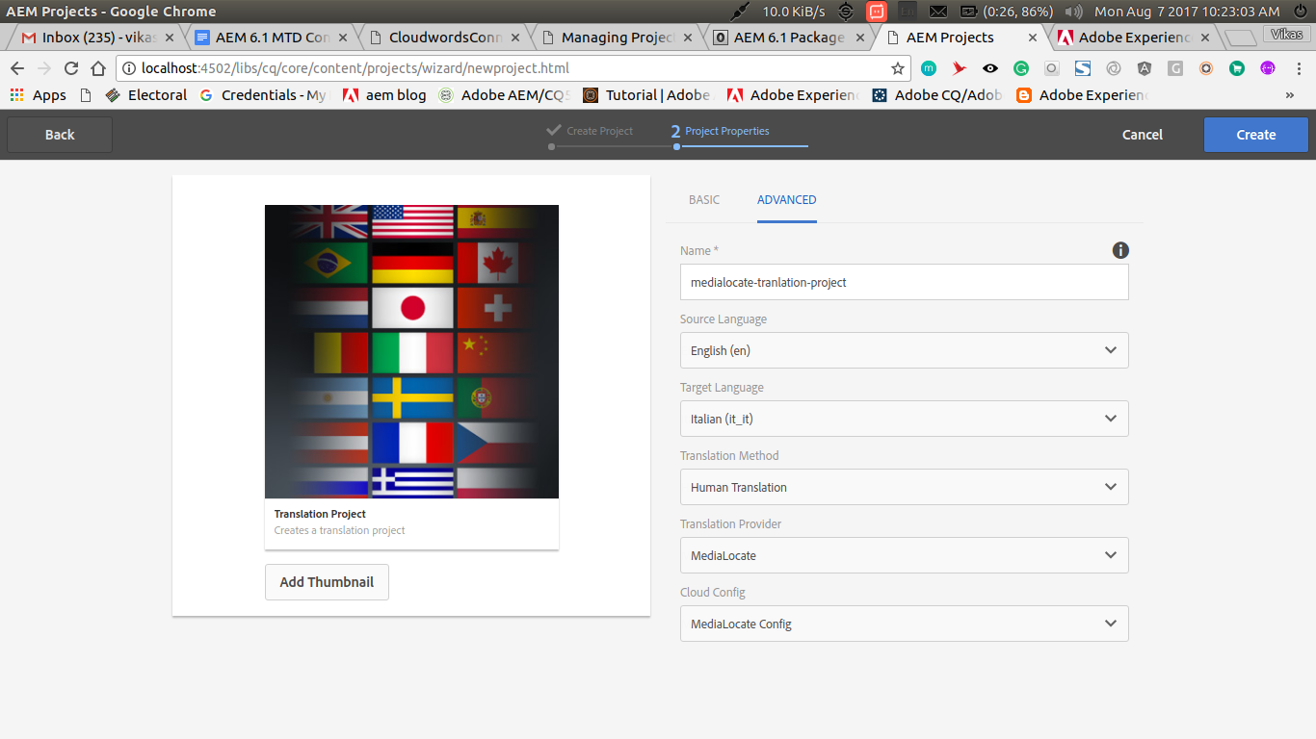

1. **A blank translation project is created with confirmation.**The confirmation asks whether you want to open your new project or to return to the console.  
   **Now click “open project”**

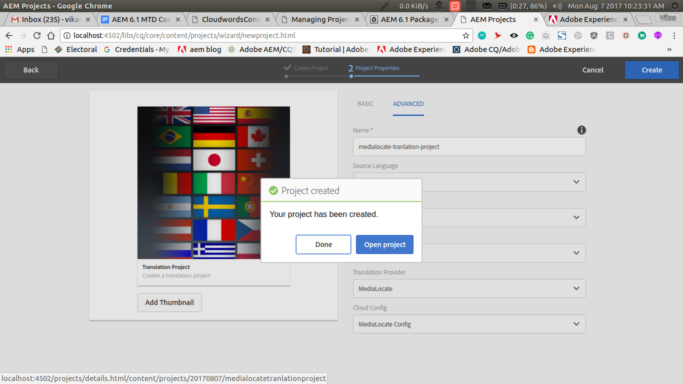

**5)** Following translation project project will appear once the project is created.

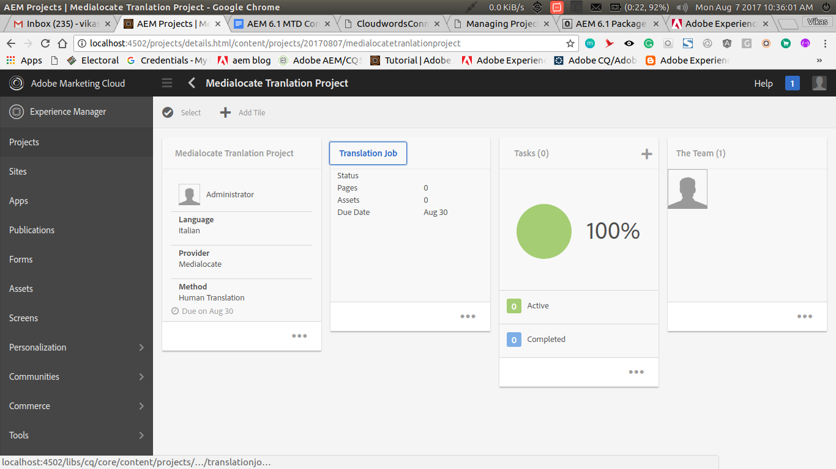

#### b. Adding Content for Translation

1. **Open Translation Job Pod :** Click on the translation job pod shown in the translation project screen to add files for translation.

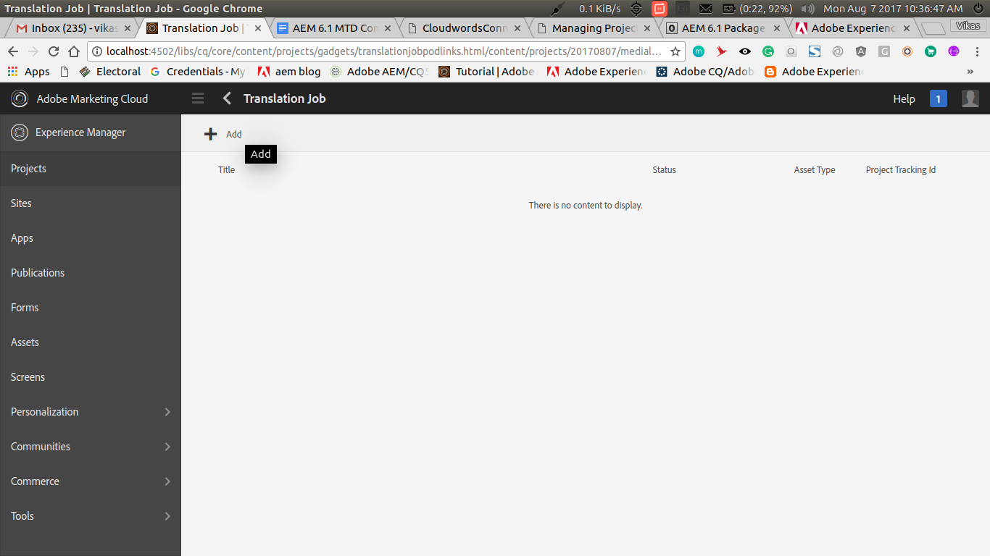

**2) Add Source files :** Click the add button to select pages for translation. Once selected click confirm to add the selected pages for translation. You can also delete the pages selected here, in the next screen.

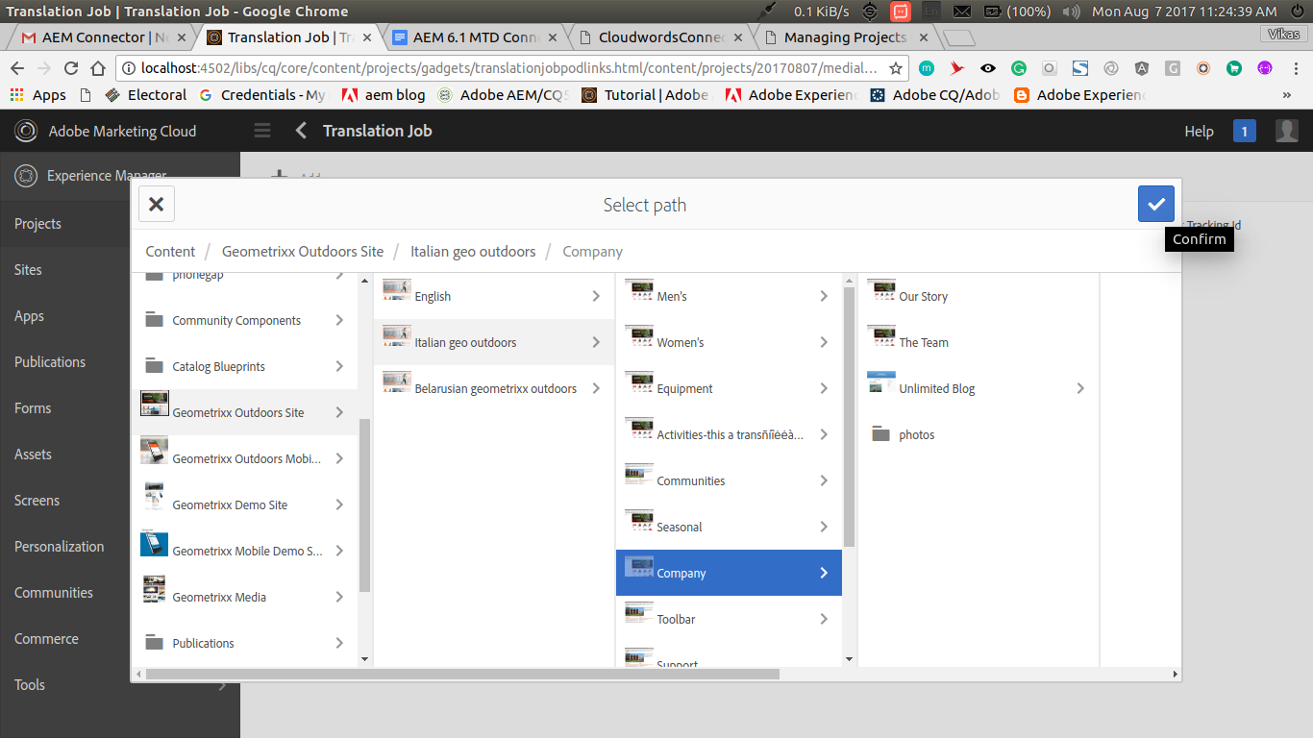

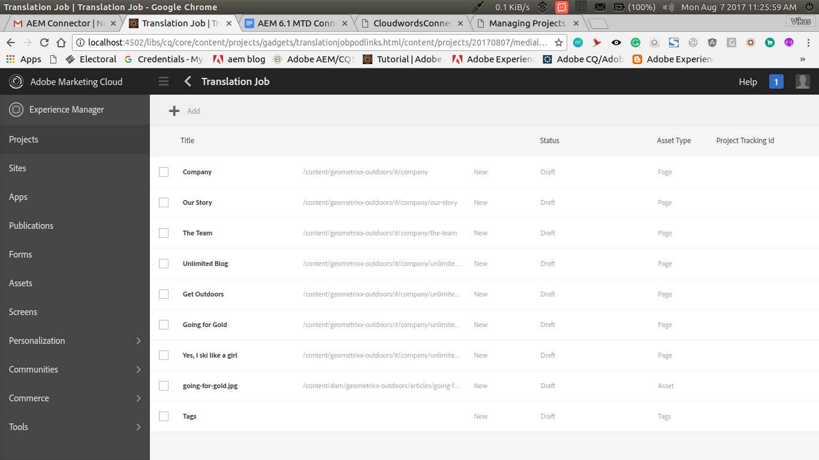

#### c. Start Translation Job

**1) Start translation Job :** Go back to the translation project screen, Click on the options button of translation job pod, that’ll open up a dropdown.

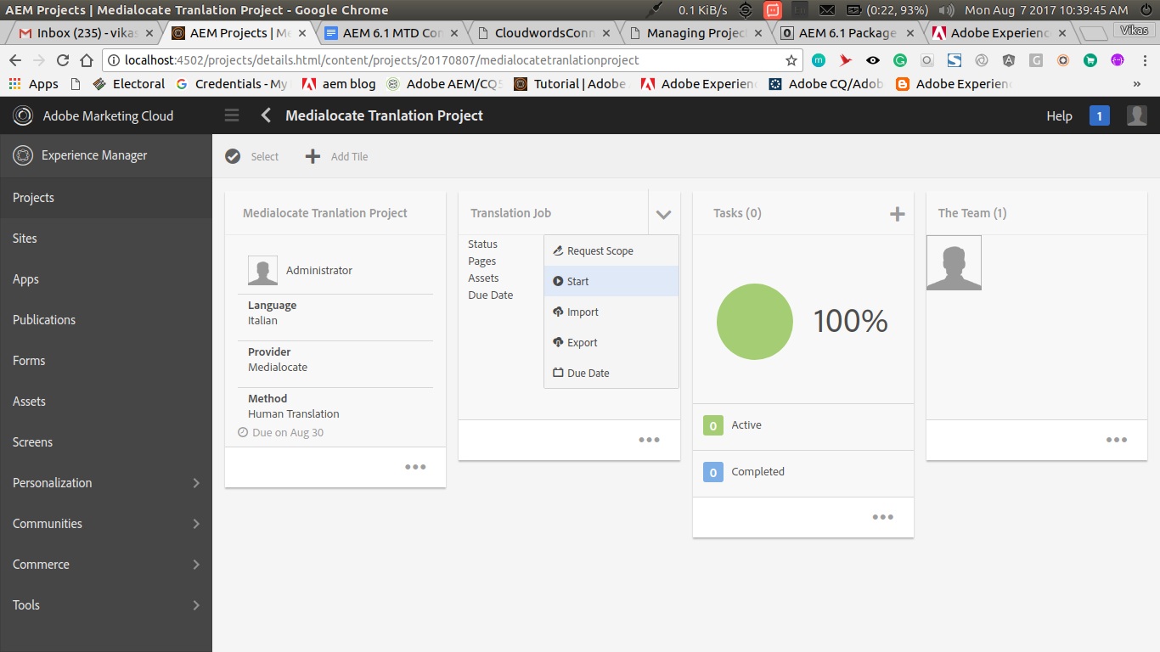

**2)** Click on start to **start** the translation job.

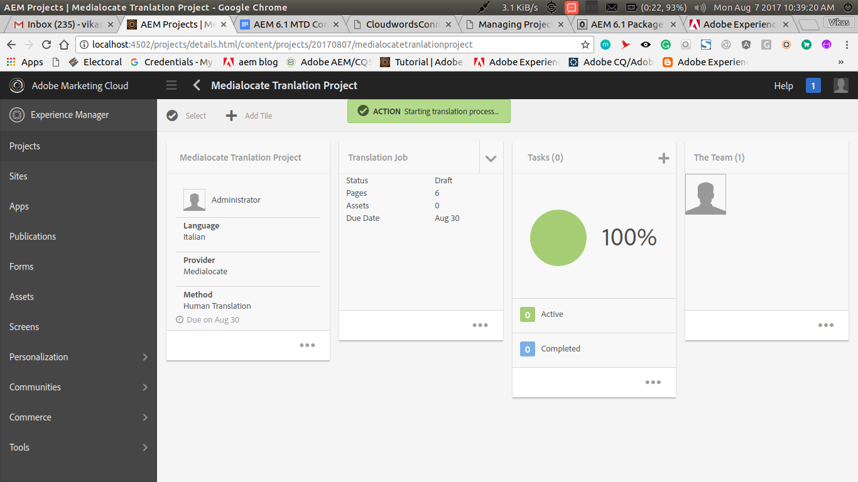

**3)** Translation Project screen will display the status of translation job.

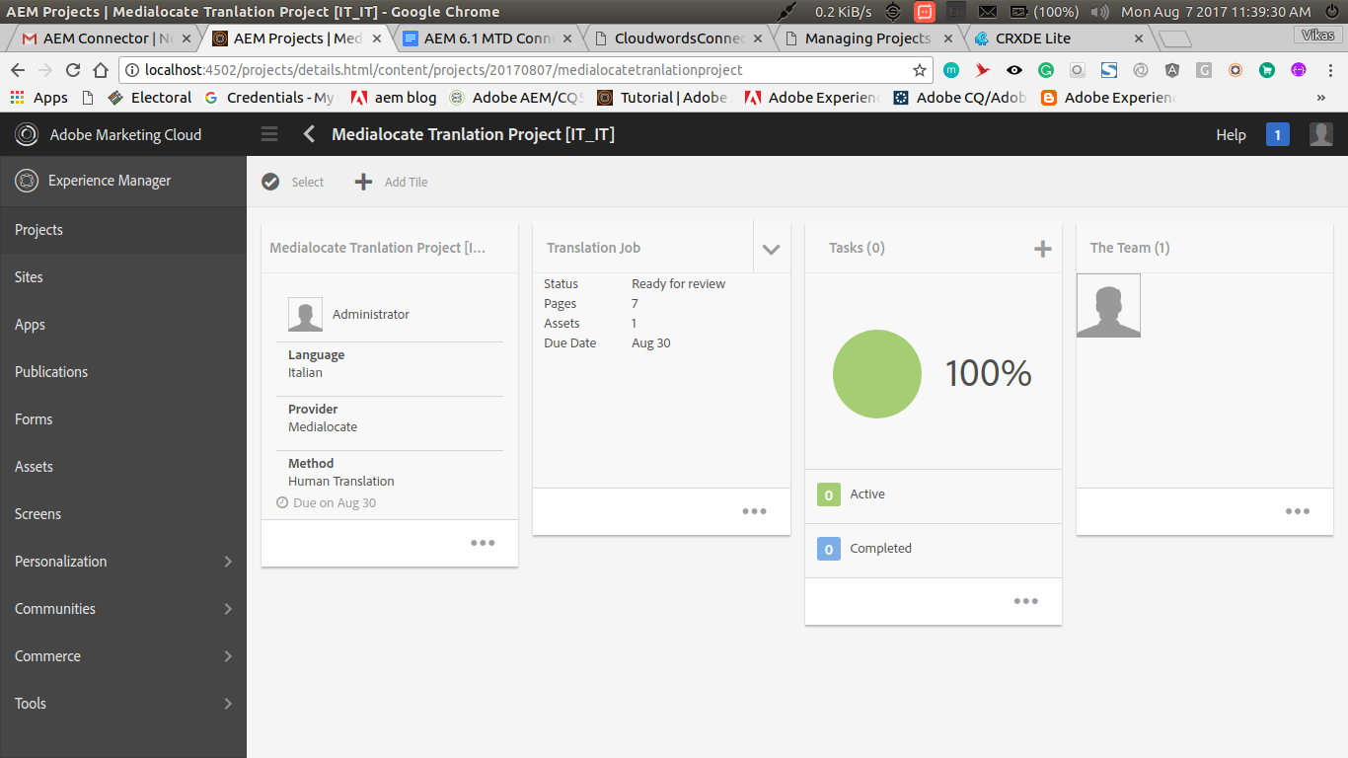

**4) Individual Status for each translation content :** You can also see the status for each translation content by clicking on the translation job pod.

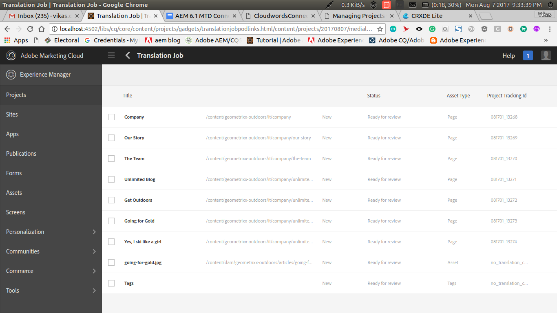

**5) Complete Translation Job :** When the translation job has been marked as “Ready for review”, “Complete” action will be available on the translation job pod, to complete the translation job.

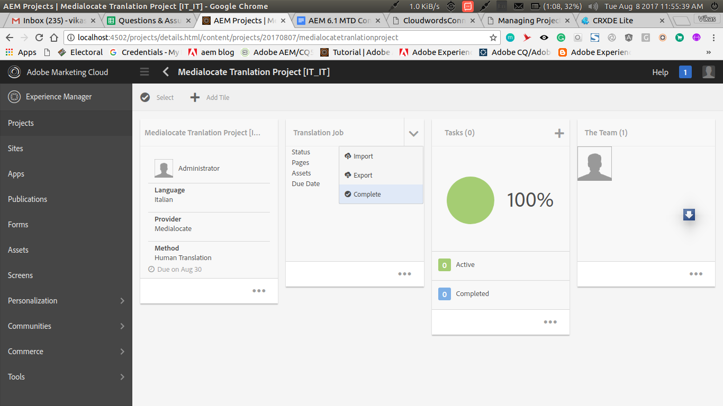

Click “Complete” to complete the translation job.

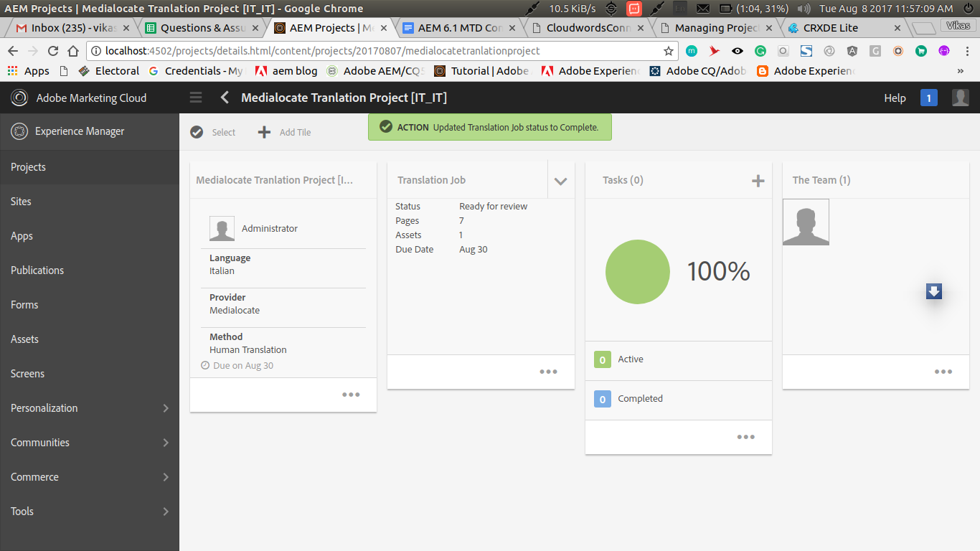

The “Complete” status will be reflected on the translation project screen.

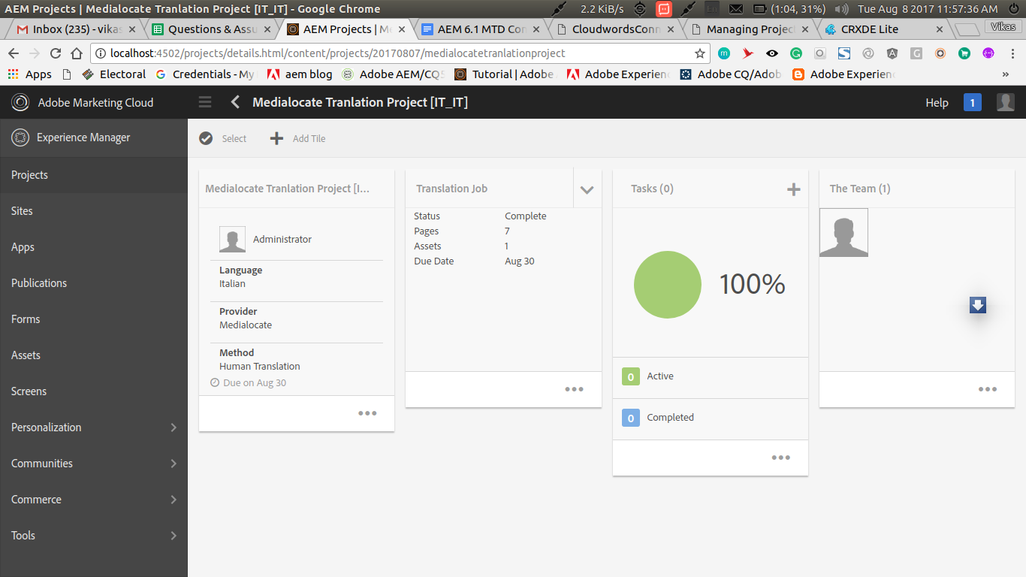

#### d. Cancel Translation Job

A project can be cancelled in “Translation in Progress” state.

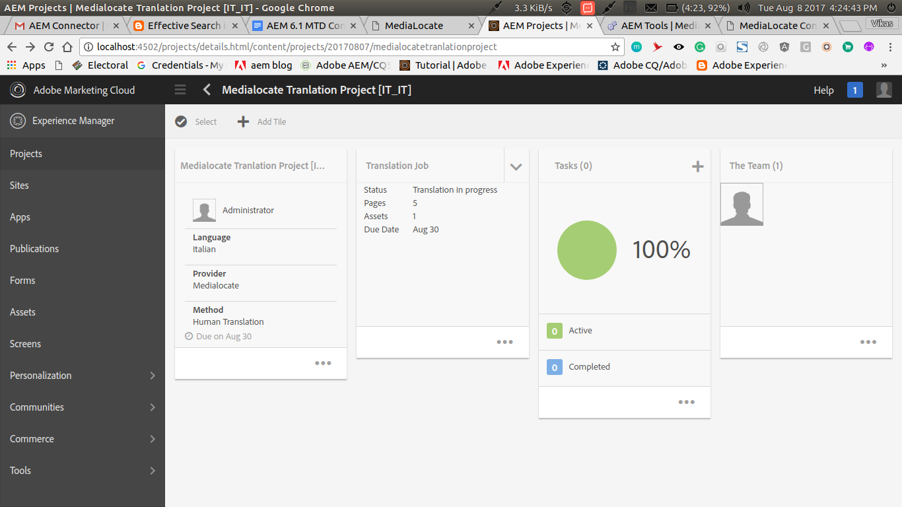

“Cancel” will be available in the translation job pod options.

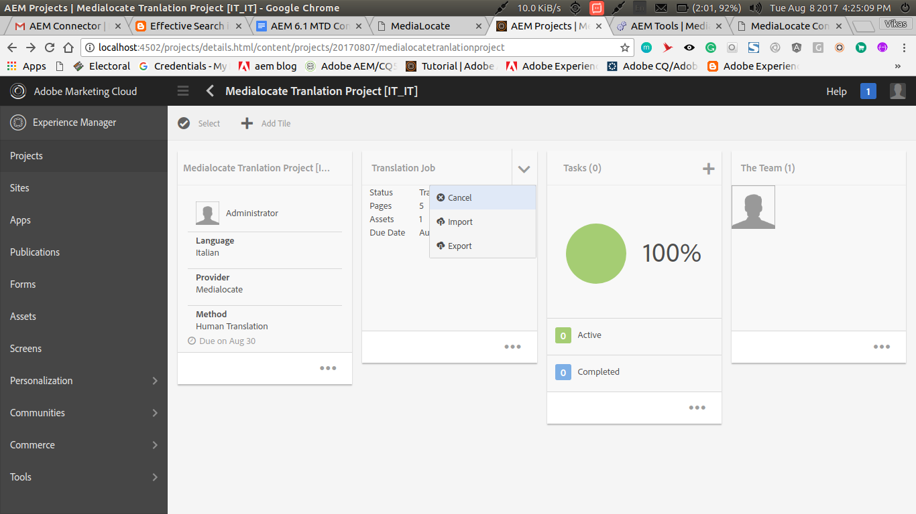

Clicking on cancel will initiate the cancellation of translation job as shown.

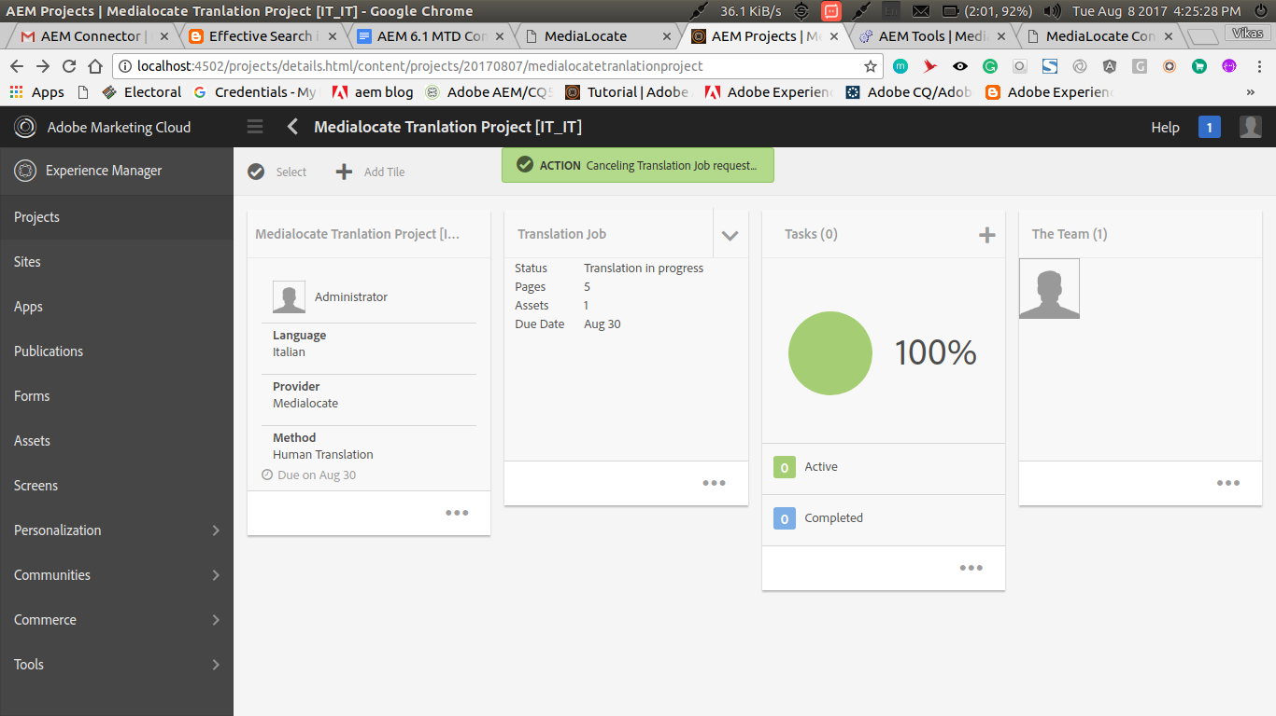

If the project has been cancelled on MTD servers then project status will be changed to Cancel otherwise it will be retained as Translation in progress.

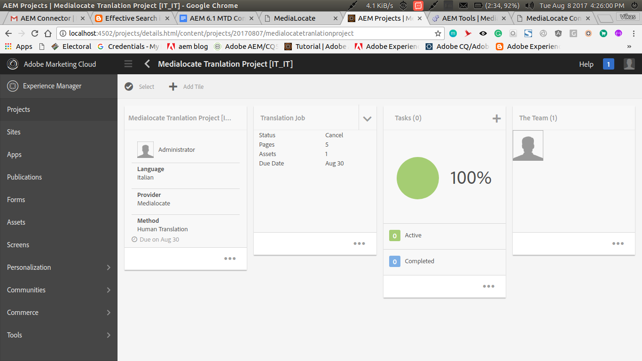

**CHAPTER 6: DATA FLOW DIAGRAM**

A **data-flow diagram** (**DFD**) is a graphical representation of the "flow" of data through an [information system](http://en.wikipedia.org/wiki/Information_system). DFD’s can also be used for the [visualization](http://en.wikipedia.org/wiki/Data_visualization) of [data processing](http://en.wikipedia.org/wiki/Data_processing) (structured design).

On a DFD, data items flow from an external data source or an internal data store to an internal data store or an external data sink, via an internal process.

A DFD provides no information about the timing of processes, or about whether processes will operate in sequence or in parallel. It is therefore quite different from a [flowchart](http://en.wikipedia.org/wiki/Flowchart), which shows the flow of control through an algorithm, allowing a reader to determine what operations will be performed, in what order, and under what circumstances, but not what kinds of data will be input to and output from the system, nor where the data will come from and go to, nor where the data will be stored.

It is a common practice to draw a context-level diagram first, which shows the interaction between the system and external agents which act as data sources and data sinks. On the context diagram (also known as the **Level 0 DFD**), the system's interactions with the outside world are modelled purely in terms of data flows across the system boundary. The context diagram shows the entire system as a single process, and gives no clues of its internal organization.

**6.1 Level 0 DFD**

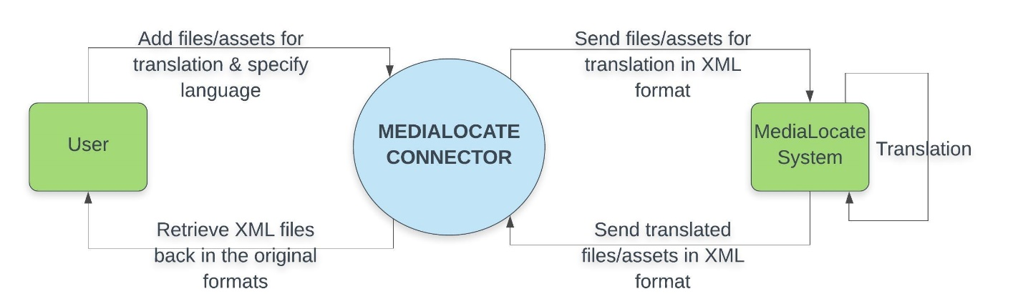

**6.2 Level 1 DFD**

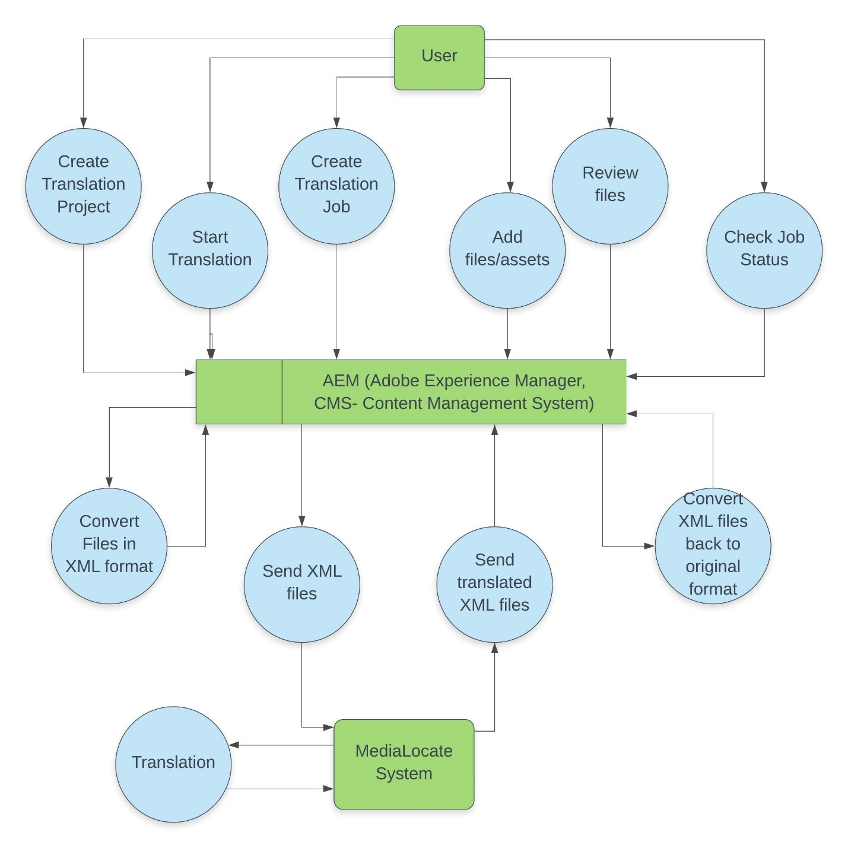

* 1. **Level 2 DFD**

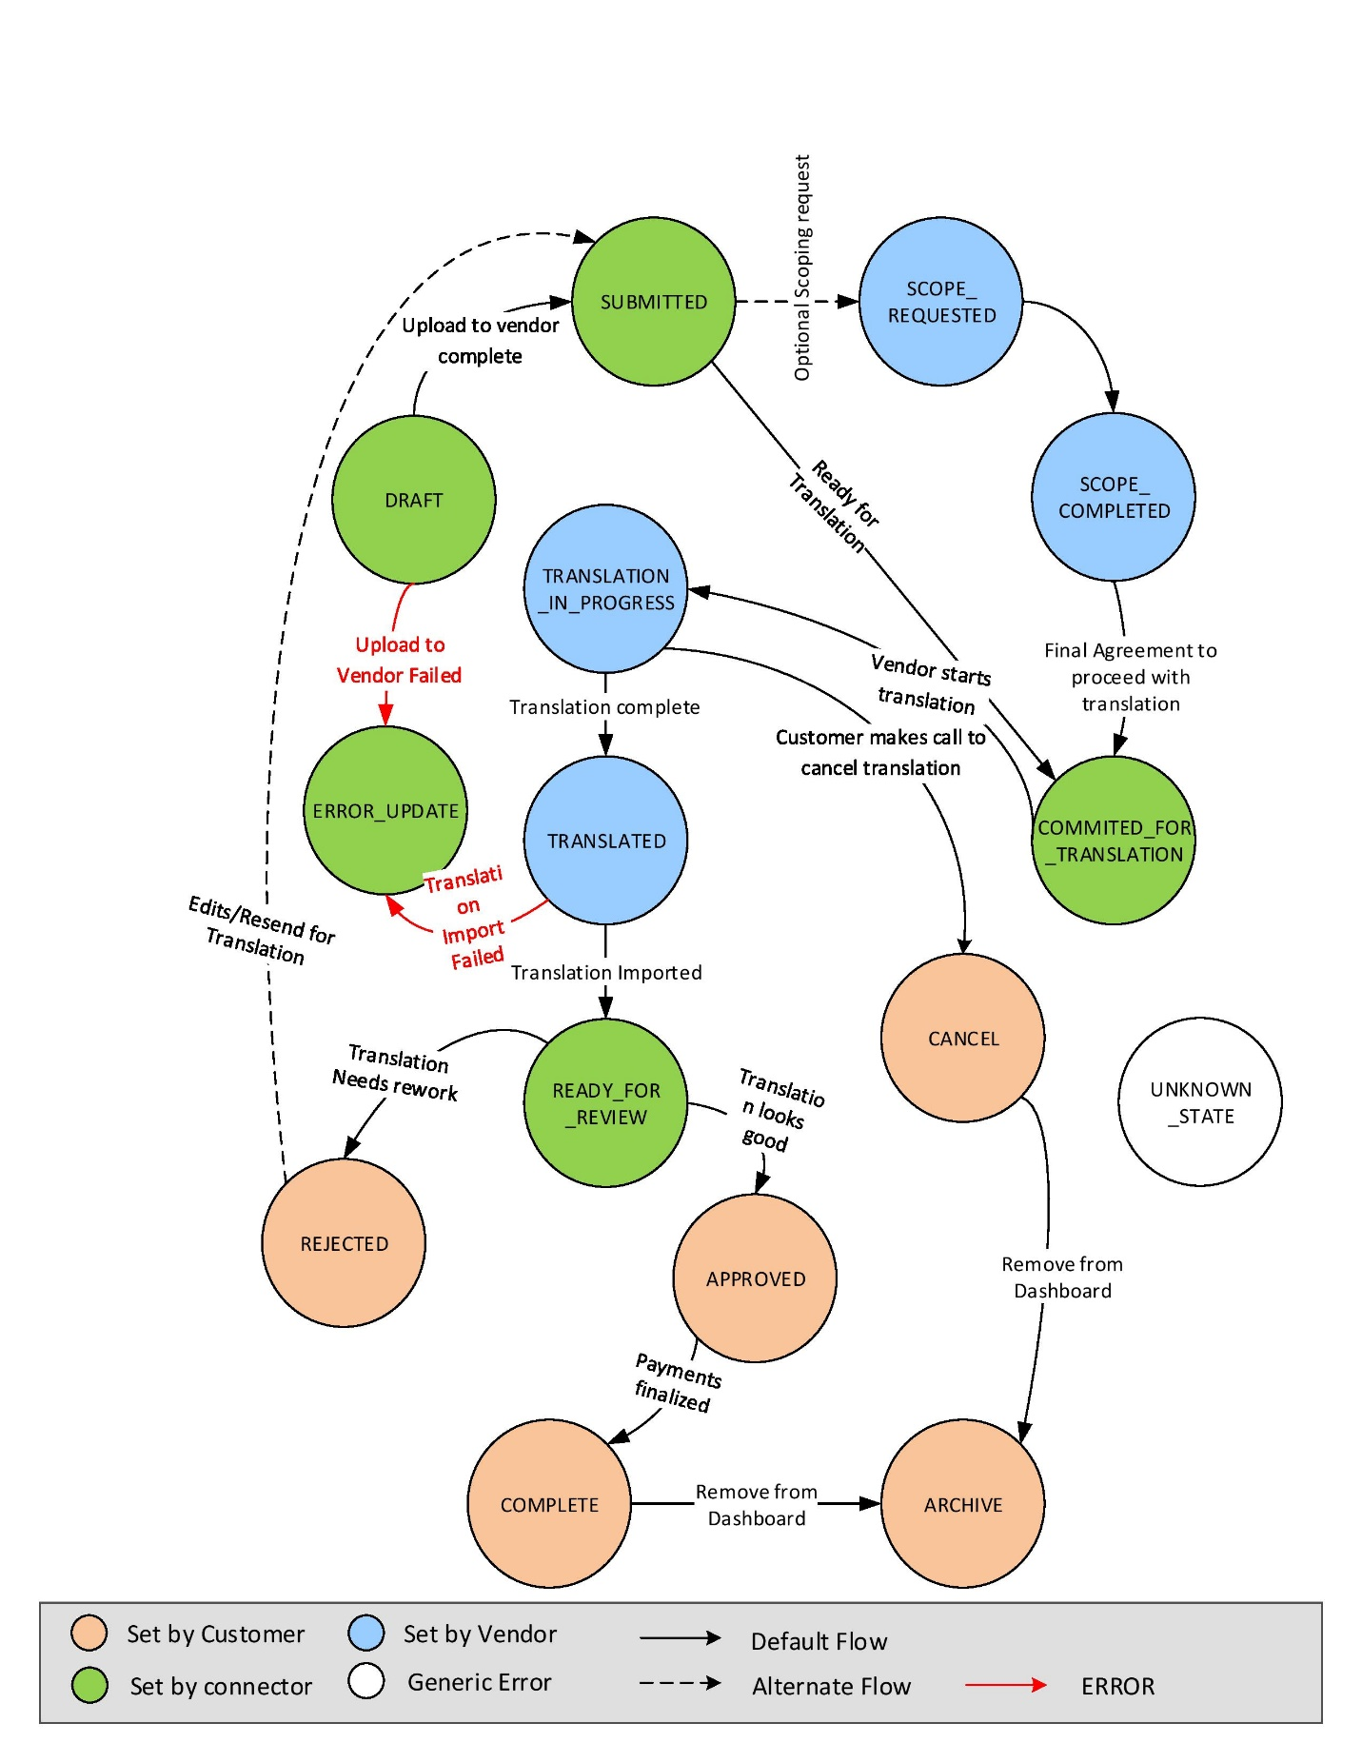

**CHAPTER 7: ENTITY RELATIONSHIP DIAGRAM**

In software engineering, an entity- realtionship model(ER model for short) is an abstract and conceptual representation of data. Entity-relationship modelling is a database modelling method, used to produce a type of conceptual schema or semantic data model of a system, often a relational database, and its requirements in a top-down fashion. Diagrams created by this process are called entity-relationship diagrams, ER diagrams or ERDs.

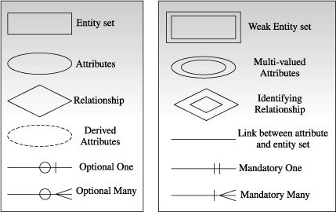

**7.1 Entity Relationship Diagram**

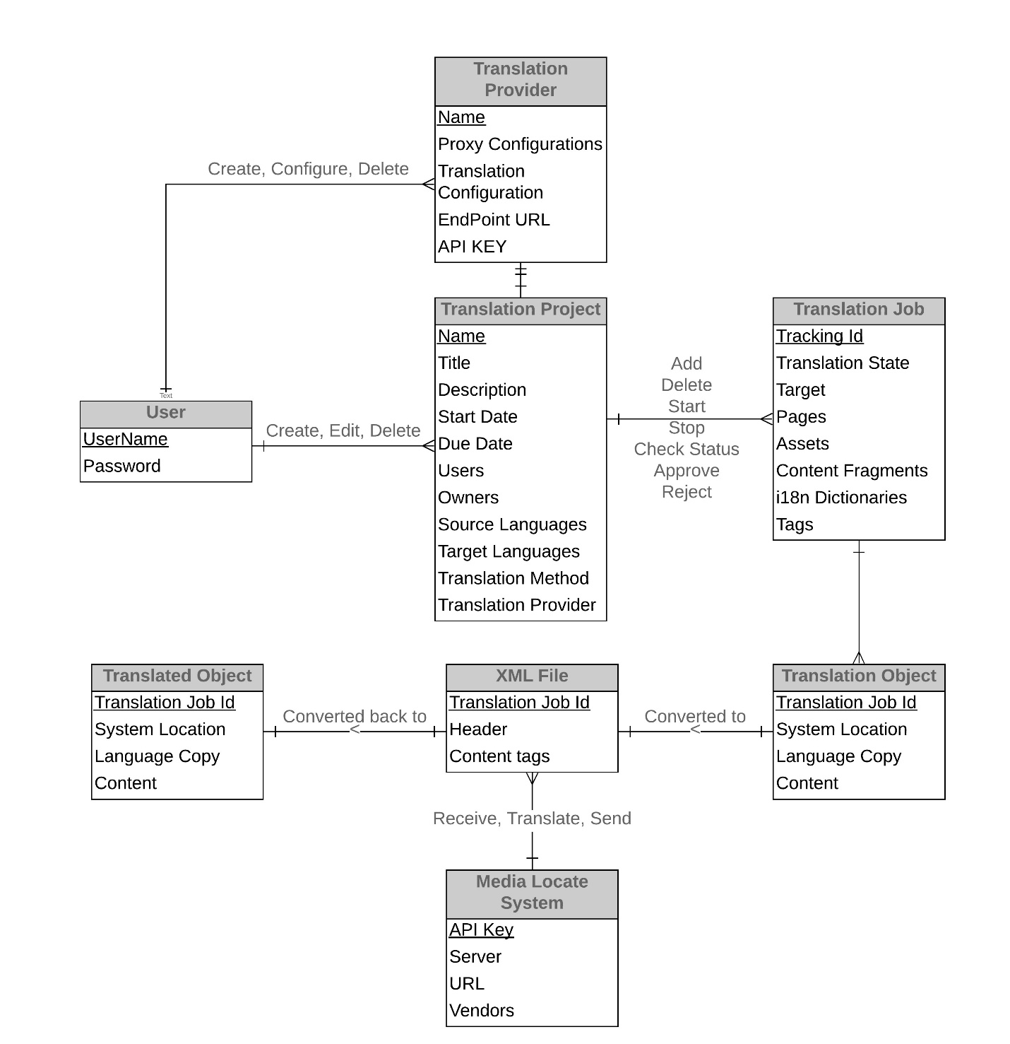

**CHAPTER 8: IMPLEMENTATION AND MAINTENANCE**

**8.1 Testing**

Software testing is a process of verifying and validatinga software application or program.The main aim of the testing is to find out the bugs in the developed system before implementing it. It is an important phase of a successful system. After codifying the whole programs of the system, a test is being performed on the system so developed. The output of the testing phase should match the expected results.

**Implementation** is the stage of a project during which theory is turned into practice. The major steps involved in this phase are:

* Acquisition and Installation of Hardware and Software

The hardware and the relevant software required for running the system must be made fully operational before implementation.

* Conversion

The conversion is also one of the most critical and expensive activities in the system development life cycle. The data from the old system needs to be converted to operate in the new format of the new system. The database needs to be setup with security and recovery procedures fully defined.

* User Training

During this phase, all the programs of the system are loaded onto the user’s computer. After loading the system, training of the user starts.

Main topics of such type of training are:

* How to execute the package
* How to enter the data
* How to process the data (processing details)
* How take out the reports

After the users are trained about the computerized system, working has to shift from manual to computerized working. The process is called ‘Changeover’.

**Maintenance** is necessary to eliminate errors in the system during its working life and to tune the system to any variations in its working environments. It has been seen that there are always some errors found in the systems that must be noted and corrected. It also means the review of the system from time to time.

The review of the system is done for:

* knowing the full capabilities of the system
* knowing the required changes or the additional requirements
* Studying the performance.

**8.2 System Security Measures**

Some of the measures can be taken as follow:-

* Various validation checks are being applied on all the forms for authenticated management of data.
* As well as various validations are also applied on the form controls so as top have reliable entry of data.
* Backup of Database must be done at the regular interval by the administrator.
* Updating the password at regular interval.

**8.3 Cost Analysis**

* **Resource sharing:**The main goal is to make all programs,equipments and data available to anyone on the network without regard to the physical location of the resource and the user.Users need to share resources other than files,as a printer.Printers are utilized only a small percentage of the time,therefore companies don’t want to invest in a printer for each computer.Network can be used in this situation to allow all the users to have any access any of the available printers.
* **High reliability:**The goal of computer network is to provide high reliability by having alternative source of supply.For example,all files could be replicated on two or three machines,so if some of them is unavailable then other copies can be used.In addition,the presence of multiple CPUs means that if one goes down,the other may be available to take over its work, although at reduced performance.For example applications, the ability to continue in the face of H/W problem is of utmost importance.
* **Saving money:**Small computers have much better price and performance ratio than larger ones.Mainframes are faster roughly by a factor of ten than personal computers but they cost a thousand times more.This imbalance has caused many systems designers to build a system consisting of personal computers,one per user,with data kept on one or more shared file server machines.In this model,the user are called client and the whole arrangement is called the Client-Server model.
* **Scalability:**The ability to increase the system performance gradually as the workload grows just by adding more processes.With centralizes mainframes, adding another processor is very expensive,so user must replace it with Client-Server model.New client and new server can be added as needed.

**8.4 Limitations**

Although utmost care has been taken to create a system which ensures proper working and is easy to use and is reaching maximum of the specifications,yet the system faces some drawbacks which are:

* The content fragments and experience fragments of a page are not added along with the pages but are getting added and translated individually.
* Administrator needs to set translation configurations by hismself/herself manually for the project to start transaction.

**8.5 Future scope of the project**

The project is currently used by our client for AEM version 6.1. Since AEM 6.4 has added a lot of new and usefull features, the project will soon be created for AEM version 6.4 by adding some more functionalities to the 6.1 code.

**CHAPTER 9: GLOSSARY**

**MTD:** MediaLocate Tracking Database Application, MTD is the application framework used by MediaLocate as Project Lifecycle tool to manage translation projects within MediaLocate.

**TMA:** Translation Management Automation, TMA is the WebService or API to the MTD.

**AEM :** Adobe Experience Manager tool for CMS.

**CMS:** Content Management System, a CMS is system which creates, publishes and manages web content.

**Activity:** In system development life cycle- a group of logically related tasks that make it possible to accomplish a specific objective; a group of related tasks.

**Analysis:** Breaking a problem into successively manageable parts for individual study.

**Cost/Benefit analysis:** The process of comparing projected savings and benefits to projected costs to decide whether a system change is justified.

**Database:** A store of integrated data capable of being directly addressed for multiple uses; it is organized so that various files can be accessed through a single reference based on the relationship among records in the file rather than the physical location.

**Database management system (DBMS):** The software that determines how data must be structured to produce the user’s view; manages, stores, and retrieves data and enforces procedures.

**Data element:** The smallest unit of a record; roughly equivalent to a field.

**Data flow:** Movement of data in a system from a point of origin to a specific destination – indicated by a line and arrow.

**Data Flow Diagram (DFD):** Graphic representation of data movement, processes, and files (data stores) used in support of an information system**.**

**Design:** Process of developing the technical and operational specifications of a candidate system for implementation.

**Documentation:** A means of communication; a written record of a phase of a specific project; it establishes design and performance criteria for phases of the project**.**

**Entity:** Also called a *data aggregate*; something of interest to the user about which to collect or store data; represents a number of data elements.

**Feasibility study:** A procedure that identifies, describes, and evaluates candidate systems and selects the best system for the job.

**Form:** A physical carrier of data, of information.

**Forms control:** Coordination of forms design and use among users of forms in the organization.

**Forms design:** Evaluating present documents and creating new or improved forms that offer useful information for action.

**Identifier:** A key that uniquely identifies a record**.**

**Implementation**: In system development – a phase that focuses on user training, site preparation, and file conversion for installing a candidate system.

**Information:** A meaningful set of data that tells something about the data relationships.

**Initial investigation:** An exploratory activity that determines whether a user request is valid and feasible before a course of action is recommended.

**Interdependence:** Dependence of a system’s components on one another for effective functioning.

**Invalid Data:** Consists of problems, where the administrator tries to or accidentally fills the incorrect data into the form fields, such as incorrect date, characters instead of numbers, etc.

**Maintenance:** To keep the thing in its consistent and original condition**.**

**Model:** A logical or mathematical representation of a system that encompasses features of interest to the user.

**Modularity:** In systems maintenance – a system is constructed in modular units of a limited size to simplify maintenance when necessary; in software reliability – the ease with which a package can be modified.

**Operating System:** In data base – machine-based software that facilitates the availability of information or reports through the DBMS.

**Organization:** Implies structure and order; a procedure that determines how components must be arranged to achieve objectives.

**Password:** Identity authenticator; a key that allows access to a program, system, or procedure.

**Planning:** Is studying a project course of action and determining what is to be done to meet stated goals.

**Post-implementation review:** Evaluation of a new system after it has been in operation to determine its actual performance against expectations**.**

**Process:** A procedure that transforms input into useful output; in a data flow diagram – indicated by a bubble or a circle.

**Record:** A collection of aggregates or related items of data treated as a unit.

**Relation:** Two-dimensional table.

**Reliability:** Dependability or level of confidence; in systems work - the need to gather dependable information for use in making decisions about the system being studied.

**Security:** The protection of data or hardware against accidental or intentional damage from a defined threat.

**Set:** The group of objects consisting of similar properties.

**Source code:** A procedure or format that allows enhancements on a software package**.**

**System:** A regular or orderly arrangement of components or parts in a connected and interrelated series or whole; a series or group of components necessary to some operation.

**System design:** Detailed concentration on the technical and other specifications that will make the new system operational.

**System development:** The process of identifying the user’s needs and designing a system that meets those needs through implementation.

**System development life cycle:** A structured sequence of phases for implementing an information system.

**System integrity:** The proper functioning of hardware, programs, and physical security, and the required degree of safety against eavesdropping and wiretapping.

**Systems testing:** Testing the whole system by the user after major programs and subsystems has been tested.

**System analysis:** Reduction of an entire system by studying the various operations performed and their relationships within the system; an examination of a business activity with a view to identifying problem areas and recommending alternative solutions.

**System analyst:** A methods person who starts with a complex problem, breaks it down for analysis, and designs a better system based on specifications set in advance.

**Task:** The smallest unit of work that is assigned to one person and controlled through a project management routine.

**Unit testing:** Testing changes made in an existing or new program.

**Usability:** A criterion in software selection – easy to operate and user-friendly.

**User acceptance test:** A test that verifies for the user that the system’s procedures operate to system specifications and the integrity of vital data is maintained.

**Validation:** Checking the quality of software in both simulated and live environments.

**Variable:** A measurable quantity that has a definite numerical value at every instant.

**Variable cost:** Cost that varies with the volume of processing or number of shifts per day; examples are employee wages and costs of supplies and raw materials.

**BIBLIOGRAPHY**

**Online Sources:**

* <http://helpx.adobe.com>
* <http://forums.adobe.com>
* <http://stackoverflow.com>
* <http://www.lucidchart.com>
* <http://www.totthenew.com>